Hope Ann (Murry) Lambert
July 28, 1969 – January 6, 2005
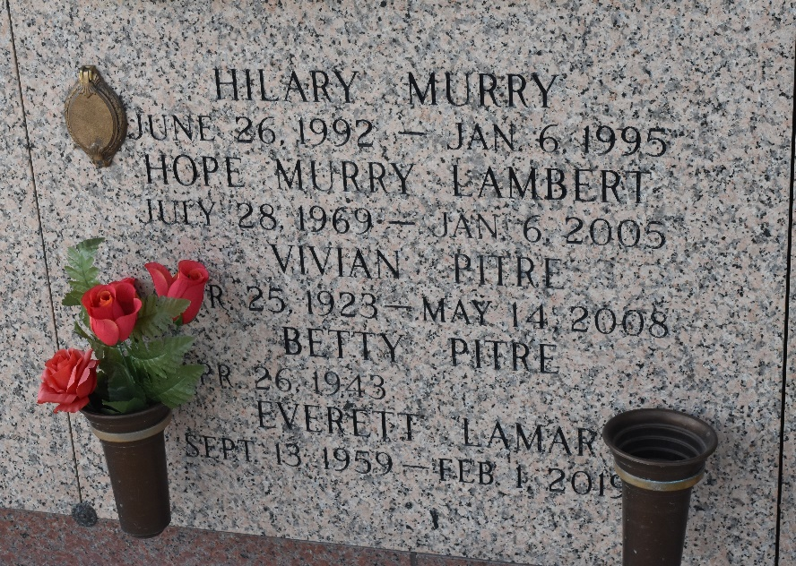

Hope Ann Murry On Thursday, January 6, 2005 At 9:35am. Age 35. A Native Of Norco And A Resident Of Laplace For The Past 7 Years. Beloved Daughter Of Betty Pitre And The Late Fabien Murry III. Mother Of The Late Hilary Murry. Sister Of Robin, Fabien Iv, Danny And Timmy Murry. Love Of Her Life Robert Lambert. Aunt Of Peyton Bordelon And Logan Leche.
Relatives And Friends Of The Family Are Invited To Attend Services. Visitation At Millet-Guidry Funeral Home, 2806 W. Airline Hwy. Laplace On Monday, January 10, 2005 From 10am To 12 Noon, Followed By Religious Services In The Funeral Home Chapel At 12 Noon. Burial In St. John Memorial Gardens, Laplace.

Times-Picayune, New Orleans, Louisiana
January 8, 2005

