Theresa (Chenier) Lambert
February 7, 1939 - December 12, 2023

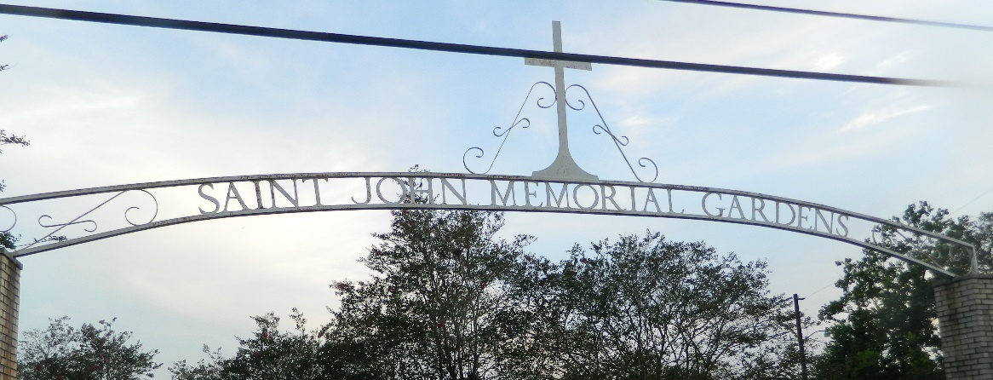

Theresa Lambert a resident of LaPlace, LA passed away on Tuesday December 12, 2023, at the age of 84.
Beloved wife of Kenneth Lambert for 64 years. Loving mother of Douglas Lambert (Penny), Donna Vicknair (Stephen), Paula Pfister (Jerry). Grandmother of Angele Hibbard (Scott), Hayden Pfister (Halie), Brittany Albarado (Trent), Blair Pfister, Brennan Lambert, Lindsay Pfister, and the late Dustin Root. Great- Grandmother of Sawyer Pfister, Luke Albarado. Daughter of the late Ovide Chenier, Sr. and Phelodia Tabb Chenier. Sister of the late Rose Caronna, Delores Simon, and Ovide Chenier, Jr. Also survived by numerous nieces, nephews, and cousins.
Relatives and friends are invited to the Visitation and Funeral Mass on Friday December 15, 2023 at St. Joan of Arc Catholic Church. Visitation will be held in church from 1:30 p.m. until 3:00 p.m. with the Funeral Mass to immediately follow at 3:00 p.m. Burial to follow at St. John Memorial Gardens.

Millet-Guidry Funeral Home, LaPlace, Louisiana
December 14, 2023

