Edward G. Landry

August 3, 1937 – July 13, 2010

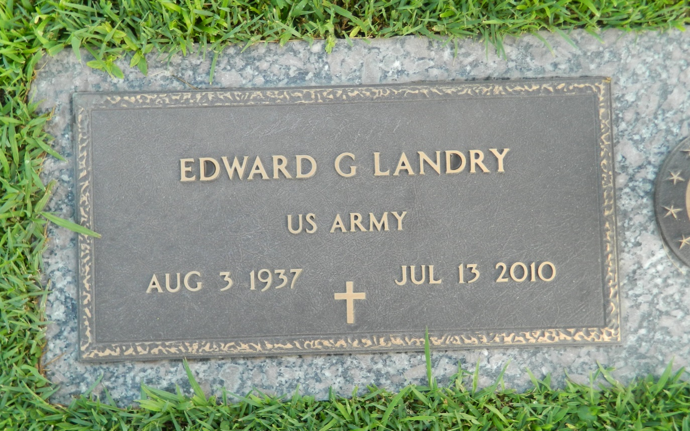

Edward "Ed" G. Landry, 72, of LaPlace, La. passed away peacefully on July 13, 2010. Ed was born 8/3/1937 in Lake Charles, La., where he was an Army Veteran. He was a salesman his entire life including the last 25 years for Standard Motor Products until his retirement in 1995. He was preceded in death by his father Louis Landry. Survivors include mother, Muriel Landry, his loving wife of 54 years Patricia "Pat" Landry, children, Karen Porter (Daryl), Keith Landry (Christine), Ricky Landry, Dennis Landry (Sammie), sister, Sue Chambers and brother, Robert "Bob" Landry. Also leaves behind 13 grandchildren, 8 great-grandchildren and 1 on the way. Ed's greatest passion was his family and sports and he was a true believer in the Lord and was an active member of Ascension of Our Lord Church.  
  
Visitation will be at Ascension of Our Lord Catholic Church, LaPlace on Friday, July 16th from 9:30 AM until 11:00 AM with a Mass to follow.  
  
In lieu of flowers, the family requests donations to be made to the church.  
  
Arrangements by Millet-Guidry Funeral Home, LaPlace.

Times-Picayune, The (New Orleans, LA) - Thursday, July 15, 2010

Contributed by Jane Edson