Patricia (Roberts) Landry

October 27, 1937 – August 29, 2010

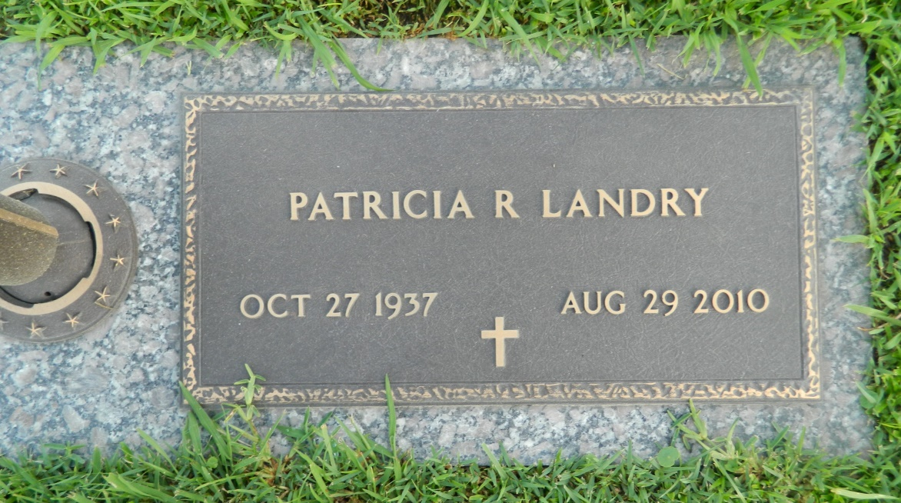

Patricia "Pat" Landry, 72, of LaPlace, La., loving mother, grandmother and great grandmother, passed away peacefully on August 29, 2010. Pat was born on 10-27-37 in Lafayette, La. Pat was an avid Chicago Cubs Fan, liked bowling and golfing, but her greatest love was her family. She was preceded in death by her husband Ed, father and mother Cliff and Robbie Roberts, Sister Polly, nephew Sonny and niece Cindy. Survivors include mother-in-law, Muriel Landry, children, Karen Porter (Daryl), Keith Landry (Christine), Ricky Landry, Dennis Landry (Sammie). Also leaves 13 grandchildren, 8 great grandchildren and 1 on the way. Pat was a true believer in the Lord and was an active member of Ascension of Our Lord Church.  
 Visitation will be at Ascension of Our Lord Catholic Church, LaPlace on Thursday, September 2, 2010 from 9:30 AM until 11:00 AM with a Mass to follow.  
 In lieu of flowers, the family request donations to be made to the church.  
 Arrangements by Millet - Guidry Funeral Home, LaPlace.

Times-Picayune, The (New Orleans, LA) - Wednesday, September 1, 2010

Contributed by Jane Edson