Nilton John Larousse
February 17, 1923 - November 3, 2019

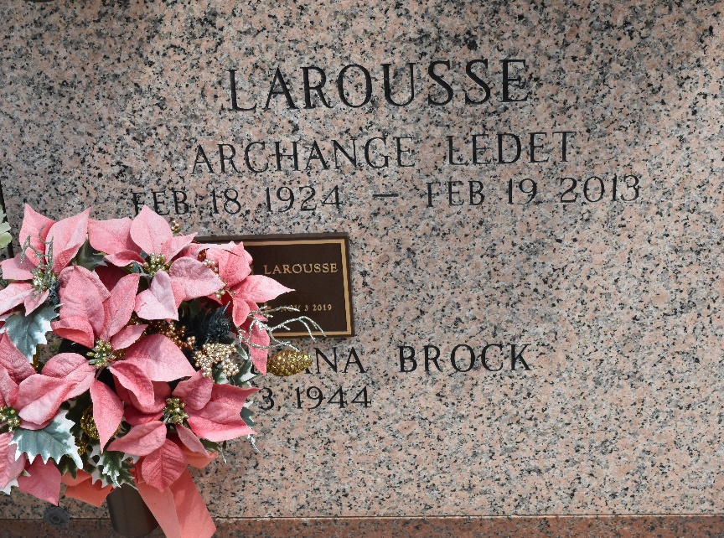

Nilton “Nit” Larousse passed away on Sunday, November 3, 2019 at the age of 96. He was a native of Gheens, LA and a resident of LaPlace, LA. He is preceded in death by his wife, Archangel “Angel” Ledet Larousse and son, Dale Joseph Larousse. Survived by his children, Larry P. Larousse (Diana), June Larousse Brignac (Leo) and Patricia "Patsy" Duhe (Tyrone). Grandfather of Jennifer Duhe, Paula Maurin, Tyrone Duhe, Jr., Troy Duhe, Tricia Curling, Christina Stout, Dawn Adams and Nichelle Vicknair. Also survived by 13 great grandchildren and 6 great great grandchildren.
His greatest pleasures in life, besides his family, were cooking, fishing and hunting. He retired from St. John the Baptist Parish Road and Bridges Dept. He was an active member of Ascension of Our Lord Knights of Columbus Council #9623 and a member of Archbishop Assembly 318 Fourth Degree Knights of Columbus. Also, he was an auxiliary deputy with the St. John the Baptist Sheriff’s Office and an active member of Civil Defense. He served in the U. S. Navy during WW II.

Millet-Guidry Funeral Home, LaPlace, Louisiana

