Wilton F. Larousse
December 4, 1932 – December 30, 1999

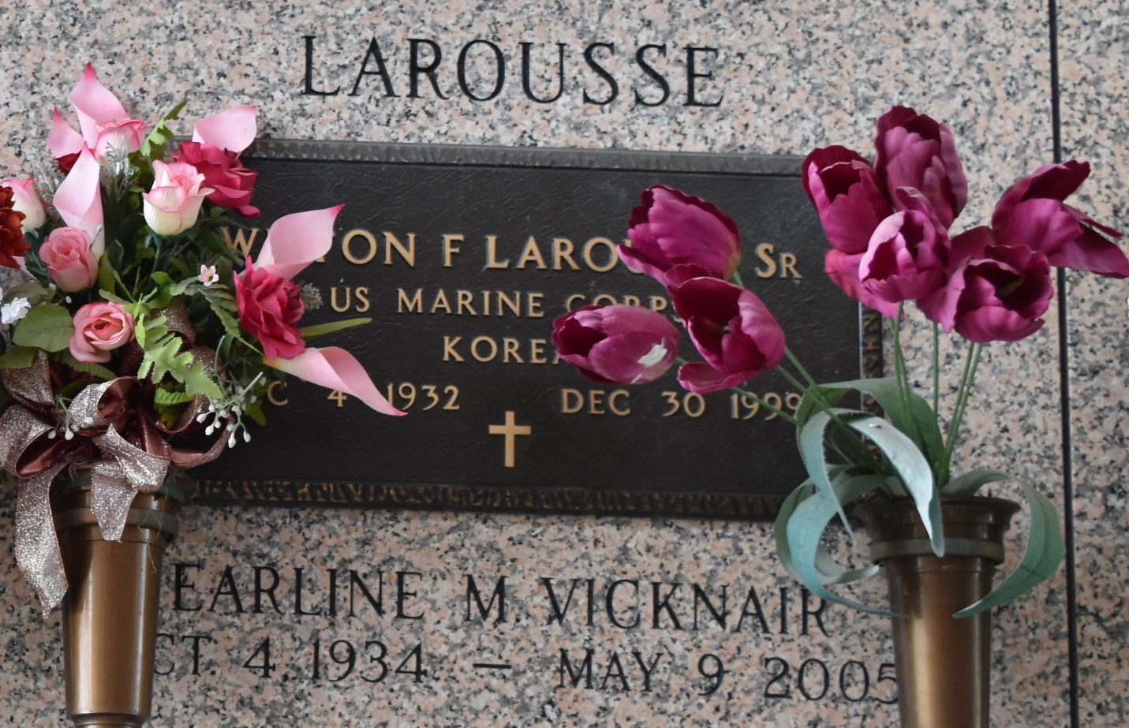

NORCO - Wilton F. Larousse Sr., 67, a native of Lockport and resident of Norco for 45 years, died Dec. 30. He was the husband of Earline Vicknair Larousse and father of Wilton Jr. and Ronald Larousse. He was also the son of the late Joseph and Louisiana Larousse and brother of Rita Deslattes and Nilton, Venton and Benton Larousse. He is also survived by six grandchildren.
Services were held Jan. 3 at Sacred Heart of Jesus Catholic Church, Norco,with interment at St. John Memorial Gardens, LaPlace.
L'Observateur, LaPlace, Louisiana
January 5, 2000

