Helen (Millet) Lasseigne
August 16, 1915 – March 7, 2006
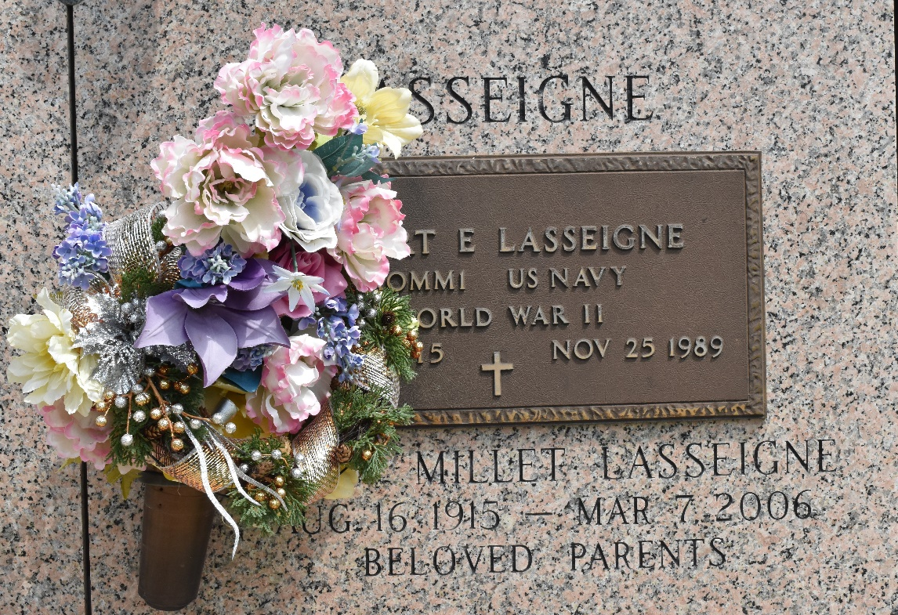

Helen Millet Lasseigne on Tuesday, March 7, 2006 at 6:00 a.m. Beloved wife of the late Robert (Bob) Lasseigne. Mother of Wayne (Whitey) and Phillip Lasseigne, Elaine DeBautte, Roline (Cookie) Alexander and the late Bobby Lasseigne, Jr. and Lorraine L. Boudreaux. Daughter of the late Edward and Carrie Weaver Millet. Sister of Ruby Lee Sherrer and the late Ted and Larry Millet. Also survived by 15 grandchildren, 28 great grandchildren and 5 great great grandchildren. Age 90 years, a native of Lions, LA and resident of Laplace for the last 55 years.
Relatives and friends of the family are invited to attend services. Visitation at MILLETT-GUIDRY FUNERAL HOME, 2806 West Airline Hwy, Laplace on Thursday, March 9, 2006 from 9:00am to 11:00 am. Followed by religious services at the funeral Home chapel at 11:00 a.m. Burial in St. John Memorial Gardens, Laplace.

The Times-Picayune, New Orleans, Louisiana
Mar. 8, 2006

