Wayne Lasseigne
June 8, 1938 – March 26, 2006

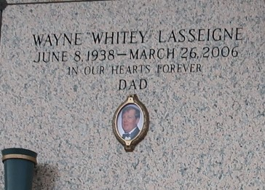

Wayne (Whitey) Lasseigne entered his eternal rest on Sunday, March 26, 2006 at 5:15 pm. Loving father of Loretta Lasseigne Sedghi and Anne Lasseigne Matherne. Father-in-law of Shawn Sedghi and Durel (D. J.) Matherne. Grandfather of Keri and Austin Matherne and Tiffany Sedghi. Son of the late Robert (Bob) and Helen Millet Lasseigne. Brother of Elaine L. DeBautte, Phillip Lasseigne and Cookie L. Alexander and the late Bobby Lasseigne, Jr. and Lorraine L. Boudreaux. He will be sadly missed by all. Age 67. A native of Lions, LA. and a resident of LaPlace for the past 60 years.

Relatives and friends of the family are invited to attend services. Visitation at Milliet-Guidry Funeral Home, 2806 W. Airline Hwy., LaPlace on Wednesday, March 29, 2006 from 9:00am to 10:45 am. Followed by religious services at St. Joan of Arc Catholic Church LaPlace at 11:00 am. Burial in St. John Memorial Gardens, LaPlace.

Published by Legacy Remembers on Mar. 28, 2006.

