Barbara (Fobb) Lassere
June 10, 1952 – January 24, 2013
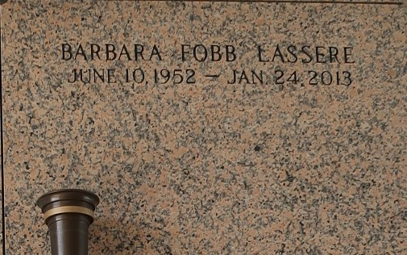

Barbara "Bobbie" Fobb Lassere, passed away January, 24, 2013, at the age of 60 years old. Daughter of the late Herbert and Azelia Fobb. Mother of Dawn and Norvel (Rochelle) Lassere, Jr. Sister of Dorothy and Herbert Fobb, Jr. and the late Ronnie, Allen and Cheryl Fobb. Grandmother of Tre, Norkita, Trokeem and Norvel, III.
Funeral services will be held at Riverlands Christian Center, 123 Redemption Way, Reserve, La. on Thursday, January 31, 2013 for 10:00 a.m. Prophet Ralph LeBlanc will be officiating. Visitation will be from 9:00 a.m. until time of service. Interment will be at St. John Memorial Gardens Cemetery, Laplace, La. Funeral entrusted to The Baloney Funeral Home, LLC., 399 Earl Baloney Street, Laplace, La., 985-535-2540. Condolences can be expressed at www.baloneyfuneralhome.com.
The Times-Picayune, New Orleans, Louisiana
Jan. 28 to Jan. 30, 2013
**

State police say a 60-year-old woman fatally shot by a St. John the Baptist Parish sheriff's deputy was pulled over because of a broken headlight. Troopers say Barbara Lassere was shot after evading a Thursday morning traffic stop.
Trooper Melissa Matey tells the Times-Picayune Lassere refused to get out of the car when she was stopped and instead brandished a gun before fleeing the scene. She says the deputy then engaged in a slow-speed chase, following Lassere to a nearby home where police say Lassere then again refused to exit the car and fired a round at the deputy. Matey says the deputy returned fire fatally injuring Lassere.
Sheriff Mike Tregre says state police will now handle the investigation into the shooting.

https://ebwiki.org/cases/barbara-lassere

