Dawn M. Lassere
June 10, 1952 – January 24, 2013
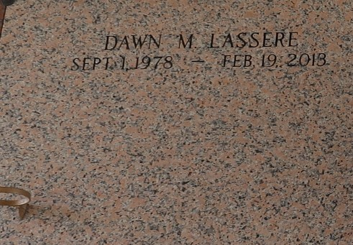

Dawn M. Lassere, passed away February 19, 2013, at the age of 34 years old. Daughter of Norvel J. Lassere Sr. and the late Barbara Fobb Lassere. Step daughter of Rhonda Lassere. Grand Daughter of Russell and Leomia Lassere and the late Herbert and Azelia Fobb. Sister of Norvel (Rochelle) Lassere, Jr.
Funeral services will be held at Riverlands Christian Center, 123 Redemption Way, Reserve, La. on Thursday, February 28, 2013 for 10:00 a.m. Pastor Steve Perrilloux will be officiating. Visitation will be from 9:00 a.m. until time of service. Interment will be at St. John Memorial Gardens Cemetery, Laplace, La. Funeral entrusted to The Hobson Brown Funeral Home, 134 Daisy Street, Garyville, La. 70051, 985-535-2516.
The Times-Picayune, New Orleans, Louisiana
Feb. 25 to Feb. 27, 2013

