Dorothy (Eagle Eye) Latapie
1936 – September 14, 2002
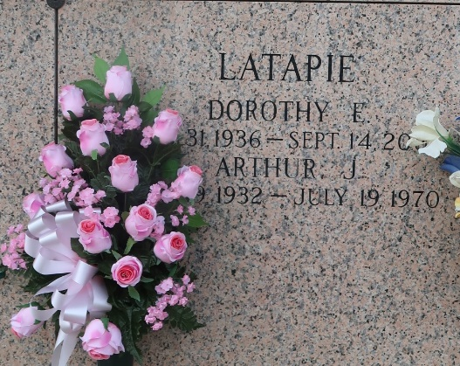
Dorothy Eagle Eye Latapie on Saturday, September 14, 2002 at 12:28 a.m. Wife of the late Arthur J. Latapie. Mother of Denise L. Tarlton, Diana L. Bordelon, Debra Latapie and James K. Rome. Mother-in-law of Charles Tarlton and Kent Bordelon. Daughter of the late Margaret Daisy O'Brien and James August Eagle Eye. Stepdaughter of the late Carlo P. Massulla. Sister of Juanita E. Waguespack, Mary Ann E. Roberts, Carlo, Henry and Edmond Massulla, the late James Eagle Eye and Harold and Walter Massulla. Also survived by 5 grandchildren and 7 great-grandchildren. Age 65 years. A native of New Orleans, LA and a resident of Kenner, LA for the past 34 years.
Relatives and friends of the family are invited to attend the funeral. A Funeral Mass will be celebrated in the Chapel of the KENNER FUNERAL HOME OF L.A. MUHLEISEN & SON, 2607 Williams Blvd. on Monday, September 16, 2002 at 11:00 a.m. Interment in St. John Memorial Gardens, LaPlace, LA. Vistation on Sunday from 5:00 p.m. until 9:00 p.m. and after 9:00 a.m. on Monday.

The Times-Picayune, New Orleans, Louisiana
Sep. 15, 2002

