Raymond J. Laviolette, Sr.
June 25, 1935 - September 14, 2023

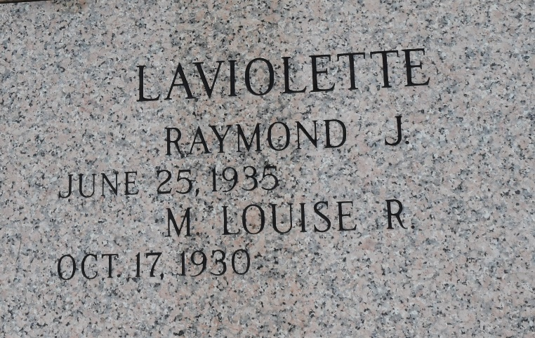

Raymond J. Laviolette, Sr. passed away on Thursday, September 14, 2023 at the age of 88. He was born in New Orleans and lived in LaPlace, LA for the past 55 years.
Beloved husband of Mary Louise Laviolette for over 69 years. Loving father of Raymond J. “Ray” Laviolette, Jr. (Claudia). Grandfather of Joshua Laviolette (Amber), Amanda Krennerich (Tim), and Jonathan Laviolette. Great grandfather of Harley Jones, Elijah Krennerich, Oakleigh Krennerich, and James Laviolette. Son of the late Robert Joseph Laviolette, Sr. and Genevieve Melancon Laviolette. Brother of Erwin Laviolette (Merle), Mary Kirkland (the late Henry), Rita Pitre (Armand), the late Hazel Dealey (the late Ken), and Robert Laviolette, Jr. (Jeannette). Godfather of Terry Gratia, Liz Durr, Sharon Dinet, Robert Laviolette, III, Damien Dinet, and the late Michael Pitre. Also survived by numerous nieces, nephews, cousins, and friends.
Proud member of the Cajun French Music Association for over 20 years.
The family would like to express their heartfelt appreciation to Compassus Hospice and his caregivers, Delores, Cynthia, and Pat for their loving care.
Relatives and friends are invited to attend the Visitation and Funeral Mass at St. Joan of Arc Catholic Church, 529 West 5th Street, LaPlace on Tuesday, September 19, 2023. Visitation at the church from 10:00 a.m. to 12:00 p.m. followed by a Funeral Mass at 12:00 p.m. Interment in St. John Memorial Gardens Cemetery, LaPlace, LA.
Rose Lynn Funeral Home, Lutcher, Louisiana
September 17, 2023

