Carl Ellis LeBlanc

February 13, 1932 – February 22, 2012

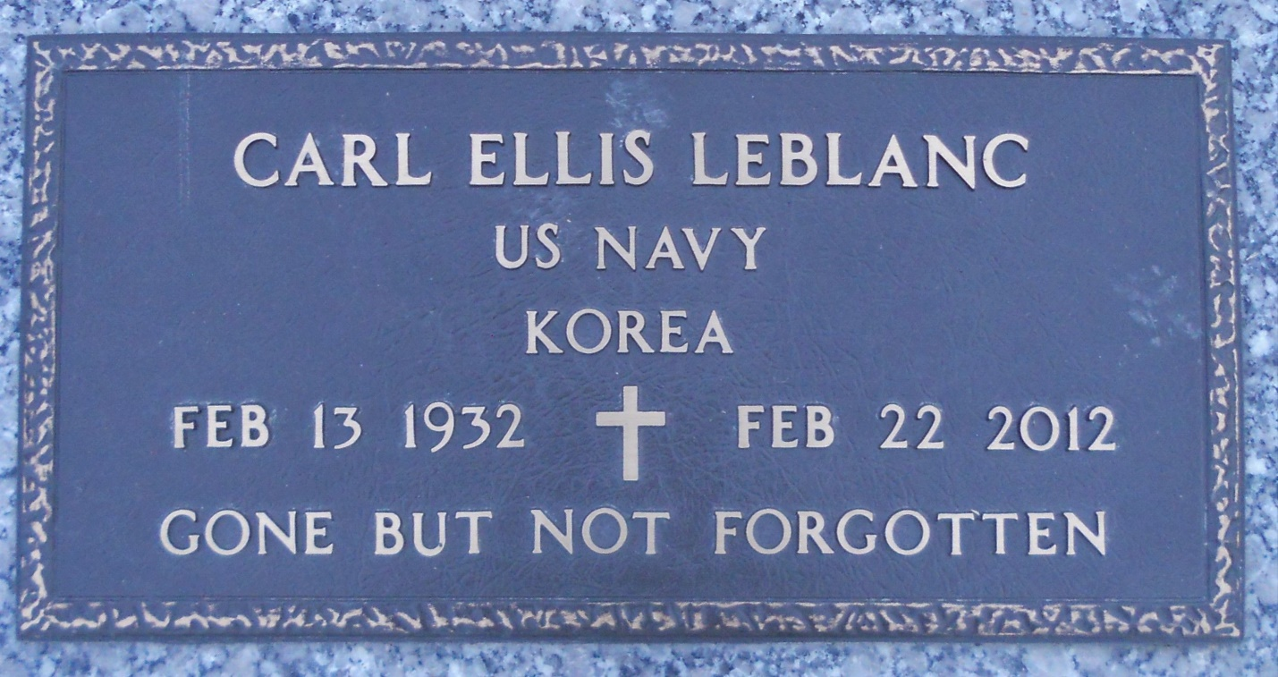

Photo by Team T Lo

Carl Ellis LeBlanc passed away Wednesday, Feb. 22, 2012, at the age of 80. He was a native of Garyville and a resident of LaPlace.  
  
He was the son of the late Charles and Beatrice LeBlanc and mother Velina Gaudin LeBlanc, father of Rock LeBlanc and Carla LeBlanc, foster father of Brad Helms, grandfather of Carl LeBlanc and Charley Snyder and brother of Sybil Newcomb (Clarence), Heman LeBlanc (Joanna), Adrian LeBlanc and Madge Kollatt (Frank). He is also survived by numerous nieces and nephews. He served in the United States Navy during the Korean conflict. He was an employee of Avondale Shipyard for 34 years.  
  
The family wishes to express their heartfelt thanks to the staff of Southeast Louisiana War Veterans Home for their dedicated care and loving support.  
  
Services were held in the chapel at Southeast Louisiana War Veterans Home in Reserve on Friday, Feb. 24, 2012. Interment followed in St. John Memorial Gardens. In lieu of flowers, donations may be made to Southeast Louisiana War Veterans Home.  
  
Arrangements were by Millet-Guidry Funeral Home of LaPlace.

Contributed by Lawrence Torres – unknown source