Everett Bennett LeBlanc
March 20, 1915 – November 30, 2004

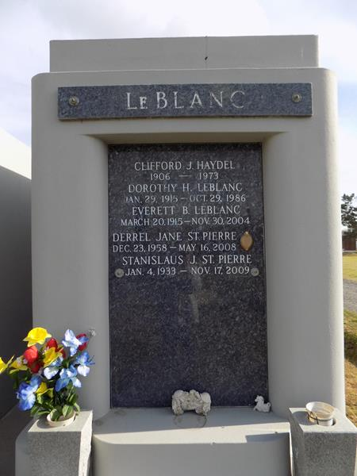

LAPLACE - Everett "Red" Bennett LeBlanc, a native of Paincourtville and resident of Reserve, died Nov. 30. He was the husband of 49 years of the late Dorothy Haydel LeBlanc, and father of Saundra "Pye" St. Pierre, Jill Vanlangendonck, Valerie Bourgeois, Kim Poche and Kerry LeBlanc. He was also the son of the late Charles and Corine St. Germain LeBlanc, and brother of Anna Berthelot, and the late Bruno, Steve and Jessie LeBlanc. He is also survived by nine grandchildren and four great-grandchildren.
He was a U.S. Army veteran of World War II, a member of American Legion Post 159 and a retired heavy machinery operator at Shell Chemical.
Services were Dec. 2 in the chapel of Millet-Guidry Funeral Home, LaPlace, with interment at St. John Memorial Gardens, LaPlace.
L'Observateur, LaPlace, Louisiana
Monday, December 6, 2004

