Lee Ann (Ellis) LeBoeuf
April 9, 1949 – April 2, 2018

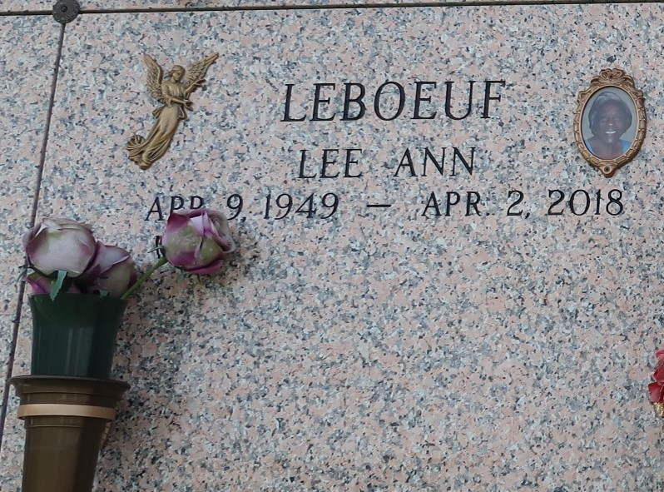
Lee Ann LeBoeuf was born on April 9, 1949, to the late Isiah and Clara Ellis Sr. She was married to the late Cyril W. LeBoeuf and to this union was born six children; Michelle(Eckert) Green, Terrence Vaughn, Danielle(Keith) Fredericks, Nedra(Robert) Craighead, Shane LeBoeuf and the late Cedric LeBoeuf. Also, two adoptive children Emanuel Albert and the late Adrian Albert. She leaves her memories to two sisters and three brothers, twenty-one grandchildren, ten great grandchildren and a host of nieces and nephews.
All neighboring churches, St. John Parish School System, Hydrochem/PSC, Baumers Food and Galatea are invited to attend a gathering of family and friends on Friday, April 13, 2018 from 5:30 to 7:30 at Treasure of Life Funeral Services, 315 E Airline Hwy, Gramercy, La. Funeral services on Saturday, April 14, 2018 for 11:00am from Greater New Mt. Zion Baptist Church, Historic East Street, Garyville, La., Rev. Wesley Anderson Jr. Pastor and Officiant. Viewing begins at 9:00 am. Entombment St. John Memorial Gardens, 2205 W. Airline Hwy, LaPlace, LA.
Treasures of Life Funeral Services, Gramercy, Louisiana
October 7, 2018

