Russell A. LeBoeuf
January 4, 1927 - February 12, 2024

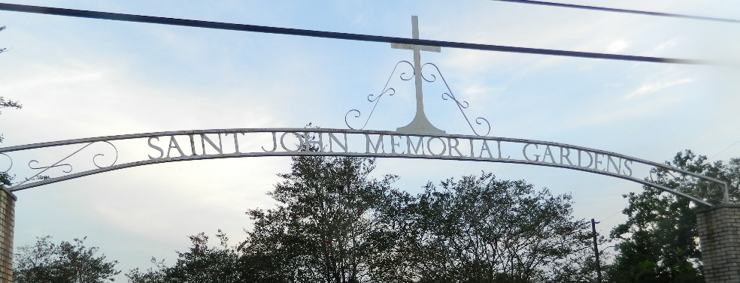

Russell A. LeBoeuf peacefully passed away on February 12, 2024, at the age of 97. Russell is a native of Convent, La, and resided also in Lions, La, but has lived since, in LaPlace for over 65 years.
He was the beloved husband of his wife, Joyce Galatas LeBoeuf for 76 years who he leaves behind. He is also survived by 3 children, Sherry Terry, Russell Mark LeBoeuf, and Susan Vinet (sp: Andre), 12 grandchildren, 18 great grandchildren, and 5 great-great grandchildren; all of whom will miss him dearly.
Russell had worked at Lousteau Auto Sales in Norco, La. for decades, and later at Rainbow Chevrolet in Laplace. During those years he earned 27 Awards for Sales production, seven of which were National Awards, including being named as one of the Top Ford Salesman in the United States, thus receiving the prestigious ‘Top Hatter’ Award in both 1968 and 1969.
He also served as a paratrooper in Japan during his service with the United States Army, in WW II and was awarded 3 Medals, The Asiatic Pacific Campaign Medal, The WW II Victory Medal, and the Army of Occupation Medal; he thereafter received an Honorable Discharge.
On Tuesday, Feb 20, 2024, relatives and friends are invited to attend the public visitation at St. Joan of Arc Church, in LaPlace La, from 9:30 a.m.-11:30 a.m. with the Funeral Mass at 11:30 a.m. Burial will be at St. John Memorial Gardens In LaPlace, LA. immediately following the services.

Millet-Guidry Funeral Home, LaPlace, Louisiana
February 15, 2024

