Barbara (Popwell) Lejeune

March 30, 1942 – February 15, 2013

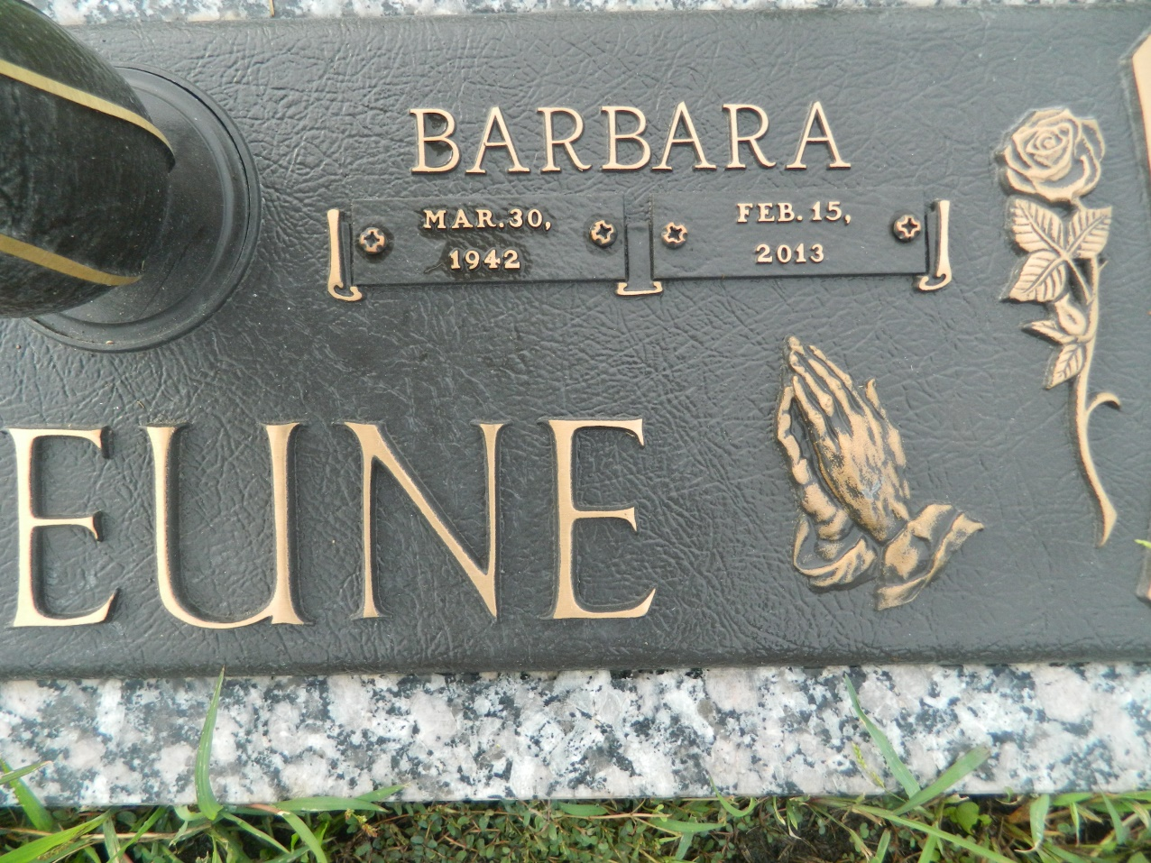

Barbara Popwell LeJeune passed away on Friday February 15, 2013. Beloved wife of John LeJeune. Also survived by 8 children, 18 grandchildren and 14 great-grandchildren. Age 70. A native of Monroe, LA and a resident of LaPlace, LA.

Relatives and friends are invited to attend services. Visitation at Millet-Guidry Funeral Home, 2806 W. Airline Hwy., LaPlace, LA on Monday February 18, 2013 from 5:00pm to 9:00pm and on Tuesday from 8:00am to 10:00am, followed by Religious Services in The Funeral Home Chapel at 10:00am. Burial in St. John Memorial Gardens Cemetery, LaPlace, LA.

Times-Picayune, The (New Orleans, LA) - Sunday, February 17, 2013

Contributed by Jane Edson