Ethel Mae (Johnson) Lennix
January 2, 1943 – May 9, 2018

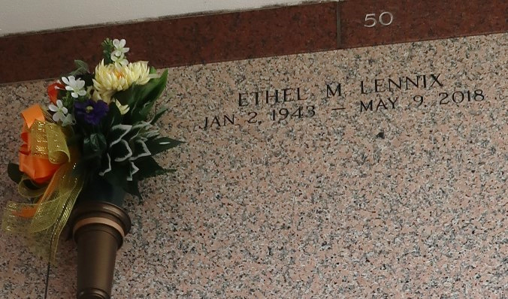
Ethel Mae "Yott" Johnson Lennix at the age of 75 yrs. departed this earthly life and entered into eternal rest on Wednesday, May 9, 2018, at her residence in Reserve, La. Mrs. Lennix was the beloved mother of Carla Lennix of Boston, MA, Warren Lennix Sr., Tyrone Lennix, and Dwayne Lennix of LaPlace, La. Sister of Ruby Fisher Stewart of LaPlace, La. Also survived by 10 grandchildren, 6 great-grandchildren, nieces, nephews other relatives and friends. A resident of Reserve, La. Ethel was preceded in death by her husband Godfrey Lennix, her mother Ethel Grey Johnson Sears, her father Eddie Johnson Sr., and her brother Eddie Johnson Jr.
Relatives and friends of the family, also Pastors, Officers and Members of Mt. Nebo Baptist Church of LaPlace, La., and all neighboring churches are invited to attend the home going celebration on Saturday May 19, 2018, at 9:00am at Mt. Nebo Baptist Church, 198 West 2nd St., LaPlace, La. Pastor Augustus G. Brown Jr. officiating. Interment in St. John Memorial Garden of LaPlace, La. Visitation will be at Mt. Nebo Baptist Church of LaPlace, La., from 8:00am until service time. Bardell's Mortuary of Mt. Airy, La., in charge. Information: 985-535-6837.
TheNewOrleansAdvocate.com
May 17 to May 19, 2018

