Marie Dale (St. Martin) Leonard
May 10, 1936 - September 8, 2018

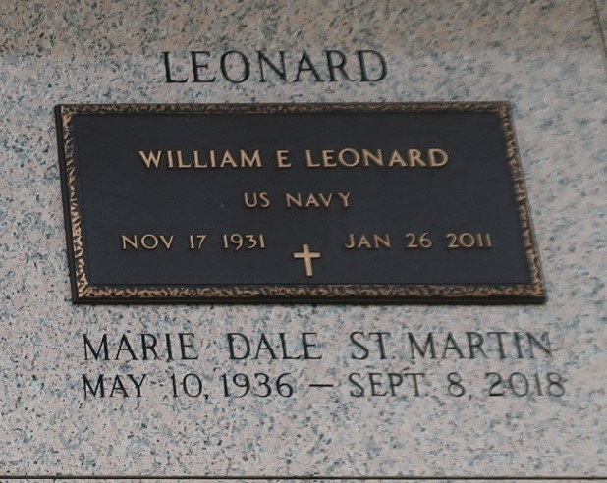

Marie ‘Dale’ Leonard passed away on Saturday, September 8, 2018. She was 82, a native and life-long resident of LaPlace, LA. Beloved wife of the late William ‘Bill’ Leonard. Stepmother of Howard Leonard. Daughter of the late Ada Soileau St. Martin and Lionel St. Martin, Sr. Sister of Dr. S.J. ‘Billy’ St. Martin, Tommy St. Martin and the late Wanda Ollar, Lionel St. Martin, Jr., Peggy Epperson and Janice Hargroder. Also survived by many nieces and nephews who are grateful for her generous spirit and guidance.
Relatives and friends are invited to attend the Funeral Mass at St. Joan of Arc Catholic Church, 529 W 5th Street, LaPlace, LA on Wednesday, September 12, 2018 at 11:30 a.m. Visitation at the church from 9:30 a.m. until 11:30 a.m. Interment in St. John Memorial Gardens Cemetery. In lieu of flowers, please consider a donation in her memory to St. John ARC (The ARC of Louisiana - St. John), 101 Bamboo Rd., LaPlace, LA 70068.
Millet-Guidry Funeral Home, LaPlace, Louisiana
September 11, 2018

