Christine Butler Lewis
Abt. 1970 – February 19, 2022

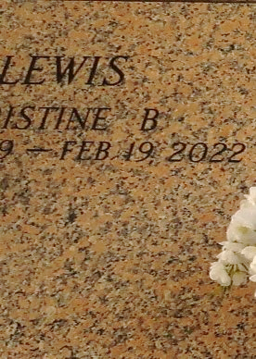

Christine Butler Lewis at the loving age of 52 transitioned and entered into eternal rest on Saturday, February 19, 2022, Daughter of the late Frankie Kennard and Andrew Jackson, wife of Herman Lewis Jr, Mother of Kereonda (Damion), Dennis, and Kiran Lewis, Grandmother of Kaleb, Damion and Domani Dennis., Sister of Tequilla Jacobs, Danielle McCoy, Irene, Dermanye, Aundra, and Brandon Butler. Christine is survived by a host nieces, nephew, other relatives, and friends.
Celebration of life on Saturday March 5, 2022, at 11:00am at Providence B.C. #2 17294 River Road Montz, La 70068. Pastor Kent B. Fredericks Officiating. Viewing will be held Saturday from 9am until service time. Interment in St. John Memorial Gardens. Laplace, La. Due to CDC (Covid 19) restrictions seating may be limited, MASK are required. Professional Services entrusted to the Caring Staff of Hobson Brown Funeral Home. 134 Daisy St. Garyville, La 70051. 985-535-2516.
The Times-Picayune, New Orleans, Louisiana
March 3 to March 5, 2022

