Doreen Lewis
February 3, 1982 – August 8, 2011

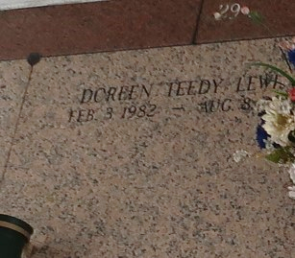

Doreen Lewis, age 29, departed this life on Monday, August 8, 2011 in Kenner, La. Daughter of Dorothy Lewis and the late Victor Sanders, Sr. Sister of Devanta and Jason Lewis, Nadia Rosary, Ivory Joe, Daryl, Reynell and Victors Sanders, Jr. Also survived by 2 aunts, 5 uncles, stepfather Brian Eugene and a host of nieces, nephews and cousins.
Service will be held at Rescue Mission B. C., 361 East 14th St., Reserve, La. on Monday, August 15, 2011 at 11:00 a.m. Interment in St. John Memorial Cemetery, LaPlace, La. Visitation will begin at 10:00 a.m. at the Church. Rev. Devin Mason. Pastor, Officiating. Services Entrusted to Hobson Brown Funeral Home Garyville, La 70051 (985) 535-2516.
The Times-Picayune, New Orleans, Louisiana
Aug. 14, 2011

