Ellsworth F. Lewis

May 13, 1929 – May 20, 2008

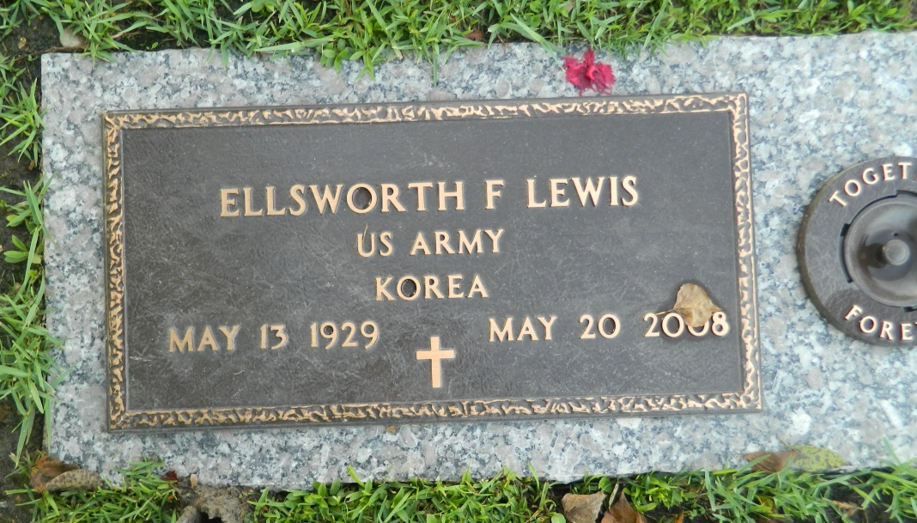

Ellsworth F. "Lou" Lewis passed away at his residence on Tuesday, May 20, 2008. He was 79. Mr. Lewis was born and reared in New Albany, IN, and has made Louisiana his home for the past 50 years. He retired from the construction industry where he served as Project Manager on many housing developments in this area. Mr. Lewis was a member of the First Christian Church of Greater New Orleans in Metairie and was a former member of the Gem and Mineral Society of New Orleans. Building houses, fishing, hunting rocks and his grandchildren were his greatest joys in life.

He is survived by his beloved wife of 57 years, Julia Short Lewis; sons, Timothy Lewis of Bakersfield, CA, Christopher Lewis of Kenner and Aaron Lewis of Temecula, CA; his favorite playmate, pal and great-grandson, Sebastian Michael Lewis; brothers, Cecil Lewis and Lee Roy Lewis; and many nieces and nephews. He is preceded in death by daughters, Julie and Gina Lewis.  
  
Relatives and friends of the family are invited to attend the funeral. Services at the Kenner Funeral Home of L.A. Muhleisen and Son, 2607 Williams Blvd., on Friday, May 23, 2008 at 11:00 a.m. Visitation from 9:30 a.m. until time of service on Friday. Interment in St. John Memorial Gardens, LaPlace.

Times-Picayune, The (New Orleans, LA) - Thursday, May 22, 2008

Contributed by Jane Edson