Joyce (Telfair) Lewis
March 12, 1943 – July 1, 2017

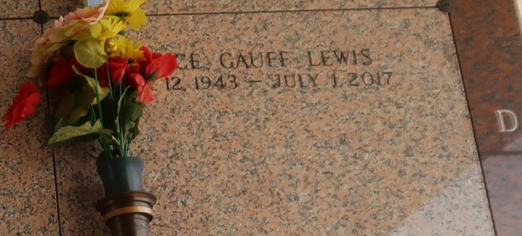

Joyce Telfair Gauff Lewis, affectionately known as “Jall” seen her Heavenly Father’s face on Saturday, July 01, 2017. Joyce was born March 12, 1943 in Garyville, LA to the late Isiah Telfair, Sr and Albertha Berry Telfair Williams. She was adopted by the late Will and Martha Dennis. She leaves behind her children Deborah Gauff (Kurt Nelson), LeDenia Gauff, Lenoard Gauff, Eric (Gaynell) Gauff, Kim (Dwayne) Mason, Deatrice Gauff, Yolanda Gauff, Reynaldo (LaQutta) Lewis, Timothy Lewis, and Raven Lewis. She is also survived by one Aunt Gladys Placide, 22 grandchildren, a host of great grand-children, sisters, brothers, nieces, and nephews. She was preceded in death by her husband, Isiah Lewis; her son Larry Gauff, Jr, her great- grandson Nor’Von Gauff, her brother Milton Telfair, her sisters Marion Batiste and Carolyn Hutchinson.
Relatives, friends, and church members are invited to attend the Celebration of Life at From My Heart To Yours Worship Center, 119 W 5th St, LaPlace, LA 70068 on Monday, July 10, 2017 at 11:00AM, Pastor Carla Ceaser, officiant. Entombment St. John Memorial Gardens, 2205 W Airline Hwy., LaPlace, LA 70068. A gathering of family and friends will be held on Sunday, July 09, 2017 from 6:00PM-8:00PM at Treasures of Life Funeral Services, 315 E. Airline Hwy, Gramercy, LA,.
Treasures of Life Funeral Services, Gramercy, Louisiana
October 18, 2018

