Leroy Lewis
September 27, 1938 – November 1, 2022

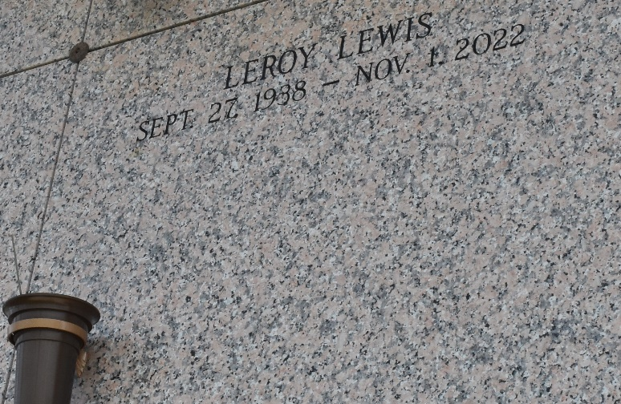

Leroy 'Paw Paw' Lewis was born in Thibodaux, LA, on September 27, 1938, to the parents of Rosie Scott Adams and Samuel Lewis. Leroy departed this life on Tuesday, November 1, 2022. Leroy eventually migrated to the New Orleans area, where he transitioned into family life with his late wife, Marilyn Lee Lewis. Leroy worked in various capacities in construction as an employee of Jefferson Parish and Gibbs Construction until he became disabled due to paralysis in the early 1980s.
Leroy is preceded in death by his mother, Rosie Scott Adams; his father, Samuel Lewis, his wife, Marilyn Lee Lewis; his children, Lloyd Cosey, Kimblyn Cosey, and Earl 'Pops' Cosey. He leaves a legacy of love to his children, Leroy (Robin) Lee, Shelly (Ulysess) Bush, Gilda (Walter) Landry, and Nadine Cosey, along with his 16 grandchildren, 19 great-grandchildren, one great-great-grandchild, other family members and friends.
His Celebration of Life will occur on Saturday, November 19, 2022, at 10:00 am at Kenner Calvary Baptist Church at 929 S. Sibley Street, Metairie, LA. Rev. Dr. James E. Turner will be officiating. Visitation will begin at 9:00 am. Interment will follow at St. John Memorial Gardens at 2205 W. Airline Hwy. Laplace, LA. Final Arrangements Entrusted to Richardson Funeral Home of Jefferson, River Ridge, LA.

The Times-Picayune, New Orleans, Louisiana
Nov. 18, 2022

