Maxine Nora Lewis
September 27, 1938 – November 1, 2022

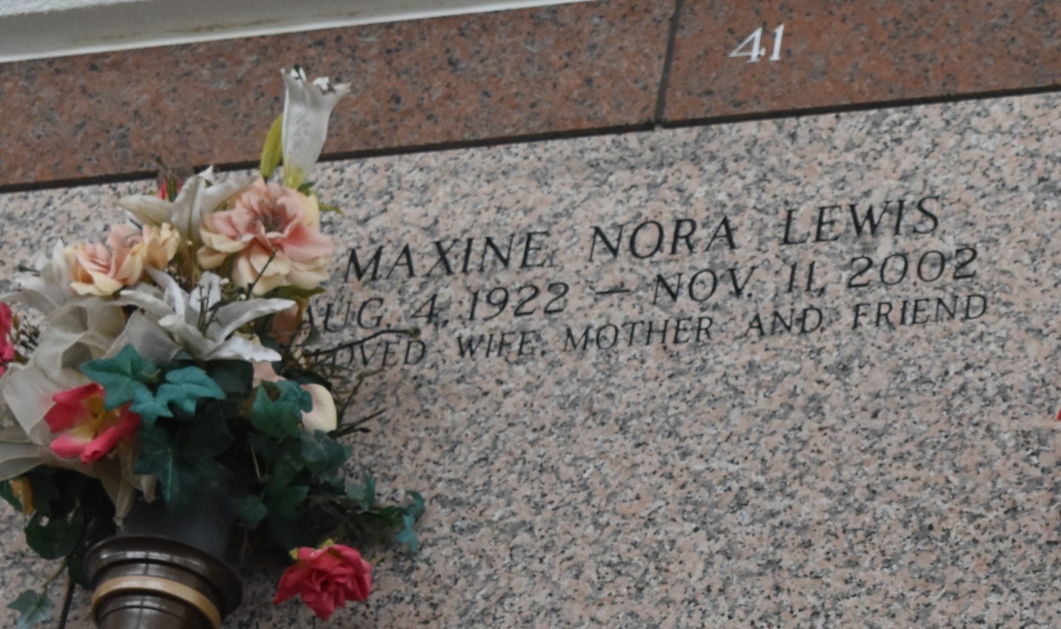

Maxine Nora Lewis. On Monday, November 11, 2002 at 12:54 PM. Beloved wife of the late Chester A. Lewis. Mother of Randy and George Lewis and the late Diane Lewis. Mother-in-law of Cheryl Lewis. Grandmother of Michael Lewis. Age 80. A native of Texas and a resident of Laplace for the past 40 years.

Relatives and friends of the family are invited to attend services. Visitation at Millet Guidry Funeral Home, 2806 West Airline Hwy, Laplace, LA. on Tuesday, November 12, 2002 from 7 PM to 9 PM and on Wednesday from 9 AM to 10 AM. Followed by Religious Services in the funeral home chapel at 10 AM. Burial in St. John Memorial Gardens, Laplace.

The Times-Picayune, New Orleans, Louisiana
Nov. 12, 2002

