Shirley H. (Mitchell) Lewis

October 27, 1932 – April 20, 2012

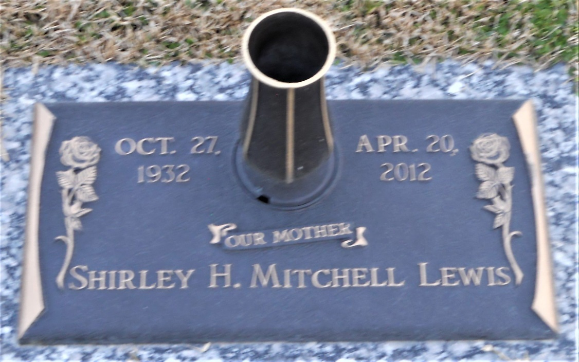

Photo by Team T Lo

Shirley Harden Mitchell Lewis, age 79, was called home to be with the Lord, Friday, April 20, 2012.   
  
Relatives and friends of the family are invited to attend her Homegoing Celebration, Wednesday, April 25, 2012, 11:00 AM, at First Community Antioch B.C., 10860 Hwy. 3125 Lutcher, LA.

Unnamed source