Erick Lightell Sr.

December 26, 1946 – June 17, 2001

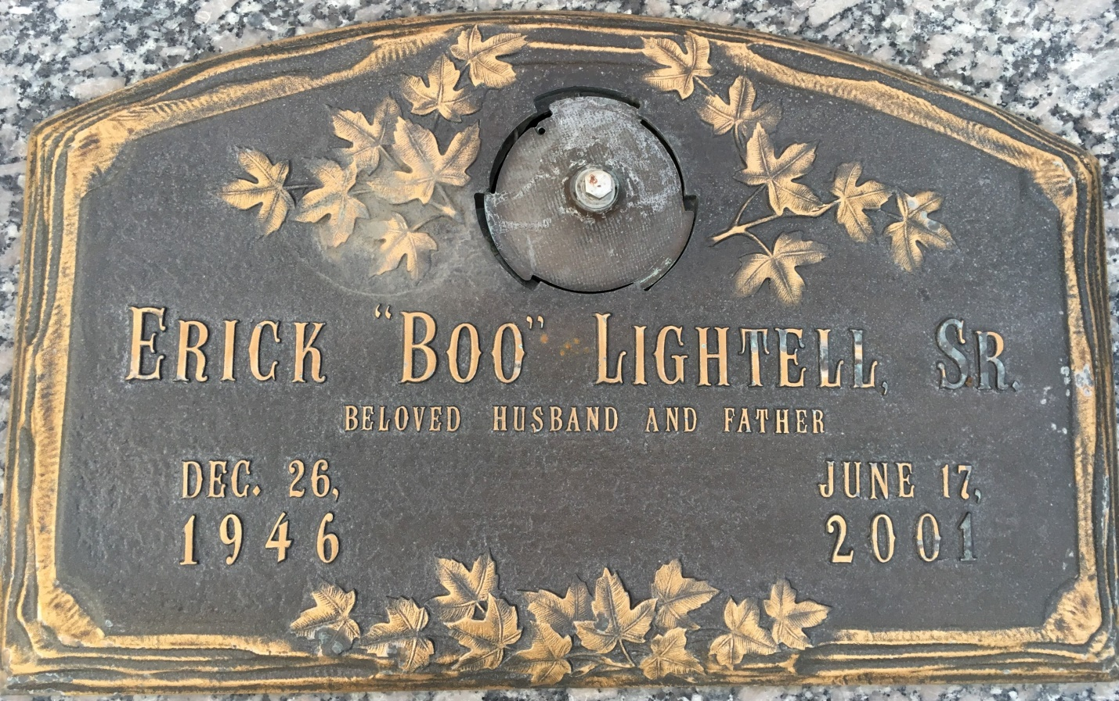

Photo by Team T Lo

Erick J. (Boo) Lightel, Sr. On Sunday, June 17, 2001 At 7:07 Pm.  
  
Beloved Husband Of Justillia Marie Ponville Lightell.   
Father Of Jojo And The Late Erick J. Lightell, Jr.   
  
Aged 54 Years. A Native Of New Orleans, La And A Lifetime Resident Of Laplace, La.   
  
Relatives And Friends Of The Family Are Invited To Attend The Funeral Services At Millet-Guidry Funeral Home, 2806 W. Airline Highway, Laplace, La On Wednesday, June 20, 2001. Followed By Religious Services In The Funeral Home Chapel At 12:00 Noon. Burial In St. John Memorial Gardens Cemetery, Laplace, La. Visitation From 9 Am Until Services.

Unknown source