James Hill Lillie Sr.
November 16, 1927 – September 28, 2021

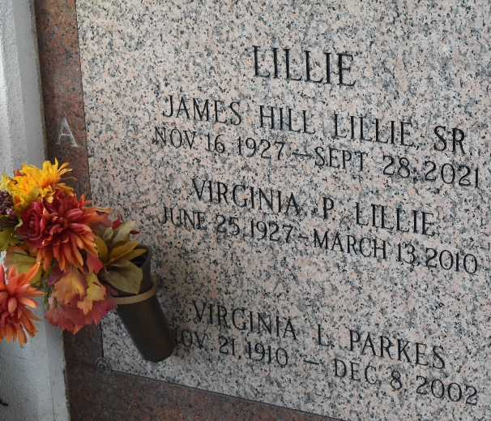

James Hill "Jim" Lillie, Sr. was born November 16, 1927 in Franklin, TN to James Fulton Lillie and Julia Hill. He attended Battleground Academy in Franklin and joined the Navy shortly before the end of WWII. Shortly after discharge he started attending college at Suwannee - The University of the South and went on to Graduate from The University of Tennessee with a BS in Chemical Engineering in August of 1950. He married Virginia Long Parkes on June 9, 1949 and they had two sons, James Hill Lillie, Jr. and John Thomas Lillie.
Jim was employed by DuPont for 33 years with assignments in Louisville, KY, Wilmington, DE, and LaPlace, LA where he retired in 1985. He was an avid golfer and enjoyed Square Dancing. He was also a member of St Joan of Arc Catholic Church.
He was predeceased by his wife Jenny Jo; parents, James Fulton Lillie and Julia Hill Lillie; and siblings, Bess Odil and the late Sybil Johnson. He is survived by his sons, James H. "Jim" Lillie, Jr. (wife, Cheryl A. Lillie) and John Thomas Lillie and many grandchildren and great grandchildren. He was a kind, loving husband, wonderful father, and good friend to all.
He will be dearly missed. Relatives and friends are invited to attend the Visitation and Funeral Mass at St. Joan of Arc Catholic Church, 529 W. 5th St., LaPlace, LA on Wednesday, October 6, 2021. Visitation at church from 9:30 a.m. to 11:00 a.m. followed by a Funeral Mass at 11:00 a.m. Interment in St. John Memorial Gardens Cemetery, LaPlace, LA.
Millet-Guidry Funeral Home, LaPlace, Louisiana

