Peter Linton Sr.
April 9, 1954 – June 2, 2022

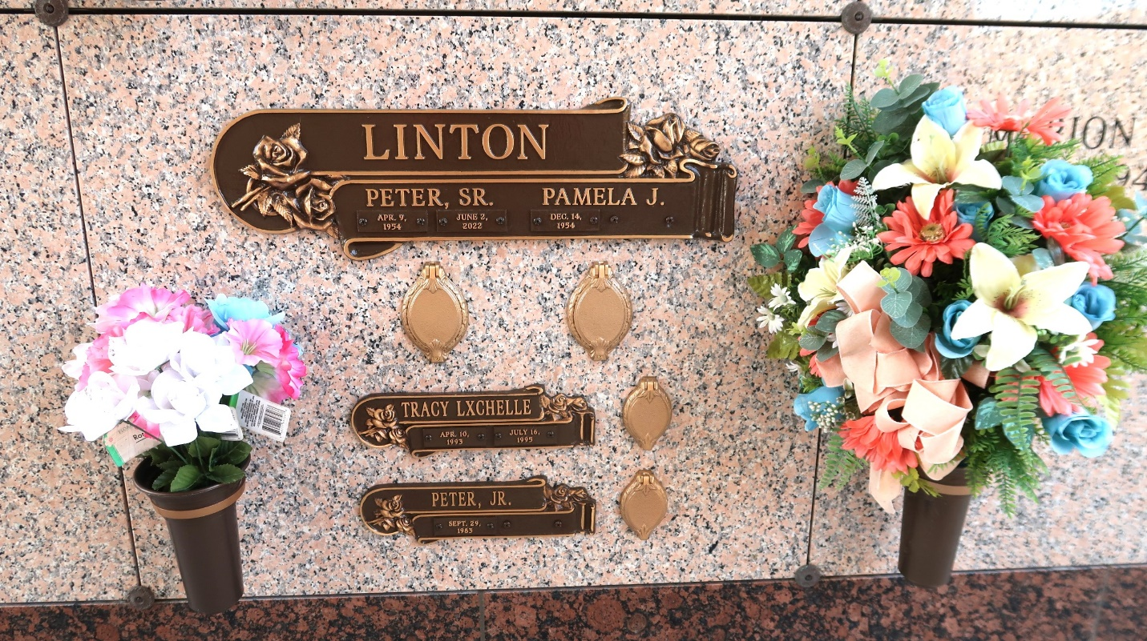

On April 9, 1954, Peter Linton was the first of twin boys born to the union of Frank Linton, Jr. and Alma Ursin Linton in Reserve, LA. He was the third of 12 children: Ernest, Donald, Paul (his twin), Cleveland, Arthur, Vanessa, Jeanette, Lori, Ronald, Wanda, and Darlene. Bro. Linton was educated in the St. John the Baptist Parish School System and graduated from Leon Godchaux High School in May 1972. He married his wife of 44 years, Pamela Johnson Linton, on May 6, 1978. There were three children: Myesha Charnell, Peter Jr., and Tracy Lxchelle Linton. Myesha blessed him with three grandchildren: Mylah Tracy Joseph, Robert Coleman III, and Rhylan Tracy Coleman. Peter blessed him with Sammie Linton, his spoiled grand-dog. All four were his pride and joy!
Bro. Linton was baptized at the Greater New Plymouth Rock Baptist Church by the late Rev. Ernest Taylor, Sr. He later joined First Community Antioch Baptist Church under the leadership of the late Pastor Ferdinand Gaines, Jr. and his current Pastor, Dr. Steven D. Beckham. He was employed by Bayside Grain Elevator, later named Continental Grain Elevator, until it closed. He later became employed with Cargill Inc. until his health failed. In 2005, this diehard Cleveland Browns fan was diagnosed with Cutaneous T-Cell Lymphoma. He bravely fought this treacherous disease with everything in him. Whether he was in Tulane Hospital or at a clinic appointment, he made it known that he was a Browns fan, not a New Orleans Saints fan! He boldly strutted his Browns paraphernalia at the Patrick F. Taylor Hope Lodge, a place that was renovated by New Orleans Saints Drew Brees. This diehard Browns fan reaped the benefits provided by a Saints player. What a guy!
Bro. Linton has been on a journey that few can understand, unless they have walked for even a minute in his shoes. He and his family rallied together and kept their focus on the promises of God. No matter what it looked like; no matter what it felt like; Peter knew that God was the One in control. He knew that he was living a testimony that would one day encourage others to stand. Peter also knew that the battle didn't belong to him, it belonged to the Lord. On Thursday, June 2, Jesus "did" work it all out for him. He called him to rest from his labor! That's what it's all about, living one's life in such a way that when our obituary is read the listeners will experience joy and regard the contents of the obituary as "precious memories". This diehard Cleveland Browns fan is now among the SAINTS! Saints of God!
He leaves to cherish his memories his Wife: Pamela Johnson Linton; Children: Myesha C. Linton (James Williams, Jr.) and Peter Linton, Jr.; Grandchildren: Mylah T. Joseph, Robert Coleman III, Rylan T. Coleman and Sammie Linton (grand dog); Godchildren: Jayia Rhian Bailey, Rysean A. Brown (Diashiki), and Ashley Linton; Siblings: Ernest James, Jr. (Betty Dennis), Donald James (the late Deborah Johnson James), Paul Linton (Marcella), Cleveland Linton, Arthur Linton (Lorna), Vanessa L. Thomas (the late Albert), Jeanette Ursin, Wanda J. McGuffy (Lorne, Sr.) and Darlene Ursin; Devoted Nieces: Ronunika U. Bailey and Yolanda M. Linton; Friends: L. J. McCoy (Delores) and Lawrence Taylor, Jr. (Ezetta); Devoted Caregivers: Rashedah Batiste, Randi Bowers, Anthony Christiana, Deacon Jerry Clark, Brooke Zeringue and the entire staff of Passages Hospice, and Sandra Glory and the entire staff of Audubon Retirement Village aka John J. Hainkel Jr. Home and Rehabilitation Center; In-Laws: Cynthia J. Bardell (Dallas), Tanya M. Johnson, Elaine J. Brown (Percy), Thaddeus Jackson (Joann), and Odrie J. Nicholas (Ronald). Bro. Linton was preceded in death by his Daughter: Tracy L. Linton; Parents: Frank Linton, Jr. and Alma Ursin Linton; Siblings: Lori Linton and Ronald Ursin; Grandparents: Ora Johnson, Herbert Ursin, Ethel Mae Stewart Linton, and Frank Linton, Sr.; and In-Laws: Rosetta L. Thomas Johnson, Lennix Johnson, Oscar Johnson, and Lennix Johnson Jr.
Funeral services will be held on Thursday, June 9, 2022, at the First Community Antioch Baptist Church, 10860 Highway 3125, Lutcher, LA 70071 from 12:00 p.m. to 1:00 p.m. Dr. Steven D. Beckham, Pastor. NO PUBLIC VIEWING. The family will be available from 11:00 a.m. to 12:00 p.m. Entombment to follow at the St. John Memorial Gardens, 2205 W. Airline Hwy., LaPlace, LA 70068. Due to COVID-19 and CDC guidelines and restrictions, masks and social distancing are REQUIRED!!
Treasures of Life Funeral Services, Gramercy, Louisiana

