Vanessa Rita Linton
April 14, 1962 – January 17, 2022

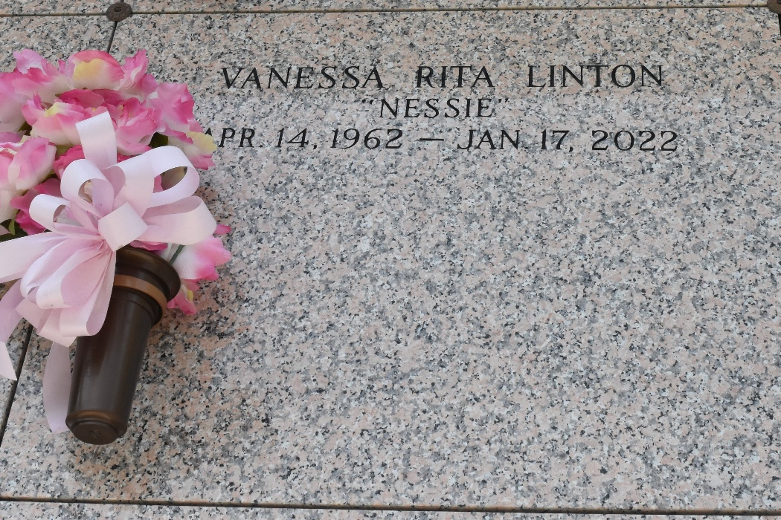

Vanessa Linton entered into the eternal presence of our Heavenly Father on Monday, January 17, 2022. Daughter of the late Earl and Betty Hilaire Linton. Sister of the late Yasmin Linton. Loving mother of Ariana Runner and the late Oscar Johnson III. She is survived by a host of aunts, uncles, other relatives, and friends.
Our Lady of Grace Catholic Church Parishioners, Seton Academy Class of 1980, employees of LaPlace Wal-Mart, and neighboring friends of the community are invited to attend the Homegoing Celebration on Saturday, January 29, 2022, for 9:30 a.m. at New Wine Christian, LaPlace, LA. Visitation begins at 8:00 a.m. Entombment at St. John Memorial Gardens, LaPlace, LA. Viewing will be held Friday, January 28, 2022, from 3 p.m. until 6 p.m. at Bardell's Mortuary, 3856 LA-44, Mt. Airy, LA 70076. Masks and social distancing will be enforced. Services entrusted to Bardell's Mortuary. Information: (504) 610-5072.

The Times-Picayune (New Orleans, LA)
Jan. 27 to Jan. 29, 2022

