Louis E. Lions Jr.
August 28, 1925 – July 11, 2000

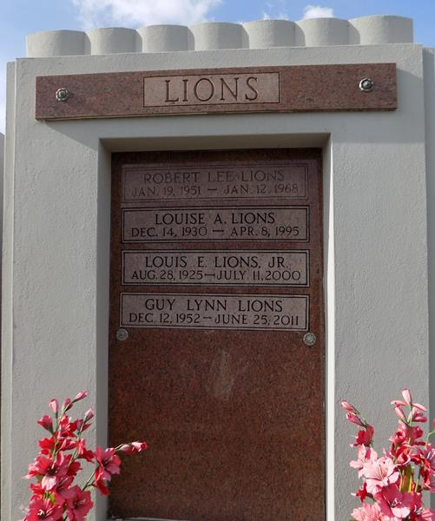

LAPLACE - Louis E. Lions Jr., 74, a native of Destrehan and resident of LaPlace, died July 11. He was the husband of the late Louise A. Lions and father of Guy Lions and the late David and Robert Lions. He was also the son of the late Louis and Lucille Lions and brother of Phyllis McCurley, Catherine Marino and the late Jude Lions. He is also survived by four grandchildren and one great-grandchild.
Services were July 14 in the chapel of Millet-Guidry Funeral Home, LaPlace, with interment at St. John Memorial Gardens.
Times-Picayune, The (New Orleans, LA)
Wednesday, December 3, 2014

