Marlene (Sutton) Lions
July 28, 1957 – December 1, 2014

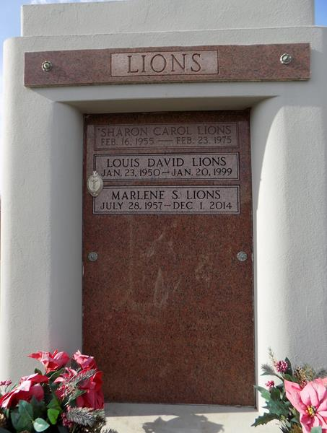

Marlene Sutton Lions was reunited with her husband in heaven on Monday, December 1, 2014. She was 57 and a life-long resident of LaPlace, LA. Beloved wife of the late Louis 'David' Lions. Mother of Amanda Ortego (Kevin) and David Lions (Shantel). Step-mother of Brande Lions Reyer (Jimmy). Daughter of Beverly Duhe Sutton and Leonard J. Sutton. Sister of Amy Sutton Broussard and Jane Sutton Reine. Grandmother of Dalton Lions, MaCayla Reyer and Alissa, Kylie and Kegan Ortego and the late Isabele Reyer. Also survived by nieces and nephews.
Relatives and friends are invited to attend a visitation on Thursday, December 4, 2014 from 6:00 p.m. until 9:00 p.m. at Millet-Guidry Funeral Home, 2806 W. Airline Hwy., LaPlace, LA. Visitation on Friday will be held at St. Joan of Arc Catholic Church, 529 W. 5th St., LaPlace from 9:00 a.m. until 11:00 a.m. followed by a Funeral Mass. Interment in St. John Memorial Gardens Cemetery. To view and sign the online guest book, please visit www.milletguidry.com.
Times-Picayune, The (New Orleans, LA)
Wednesday, December 3, 2014

