Douglas Locke
January 1, 1932 – June 29, 2006

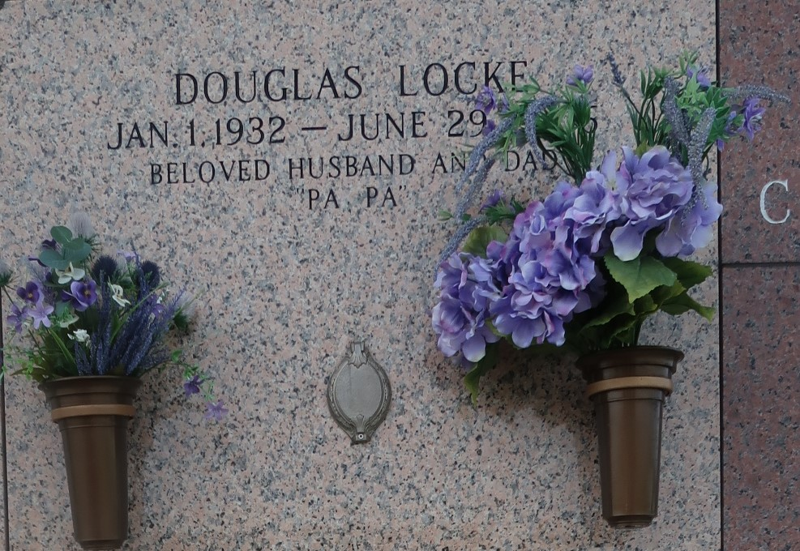

Douglas (Doug) Locke on Thursday, June 29, 2006 at 10 a.m. Beloved husband of Mary Locke. Father of Ronnie Locke, Becky Forsythe and the late Jimmy Locke. Also survived by 4 grandchildren and 2 great-grandchildren. Brother of Vera Norris of Georgia. Age 74. A native of Alabama and a resident of Laplace for the past 40 years.
Relatives and friends of the family are invited to attend services. Visitation at Millet Guidry Funeral Home, 2806 W. Airline Hwy, Laplace, on Sunday, July 2, from 5 pm to 9 pm and on Monday from 8 am to 10 am followed by religious services at the funeral home chapel at 10 am. Burial in St. John Memorial Gardens, Laplace.
The Times-Picayune, New Orleans, Louisiana
Jun. 30, 2006

