Mary (Philyaw) Locke
March 4, 1933 – September 13, 2020

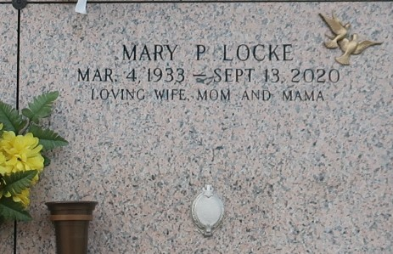

Mary Philyaw Locke gained her wings on Sunday, September 13, 2020 at the age of 87. She was a native of Andalusia, AL and was a resident of LaPlace, LA. Beloved wife of the late Douglas Locke. Loving mother of Becky Locke Forsythe (Scott) and the late Jimmy Locke and Ronnie Locke. Devoted grandmother of Adam Forsythe and Mason Forsythe. Daughter of the late Daisy Weaver Rutledge and Andrew Philyaw. Sister of Ralph Rutledge (Faye) and the late Judy Holley. Also survived by nieces and nephews.
Relatives and friends are invited to attend the visitation at Millet-Guidry Funeral Home, 2806 W. Airline Hwy., LaPlace on Saturday, September 19, 2020 from 11:00 a.m. to 1:00 p.m. followed by a Funeral Service at 1:00 p.m. Interment in St. John Memorial Gardens Cemetery, LaPlace.
Millet-Guidry Funeral Home, LaPlace, Louisiana
September 17, 2020

