Frances M. (Plantago) Loechner

August 3, 1922 – December 26, 2001

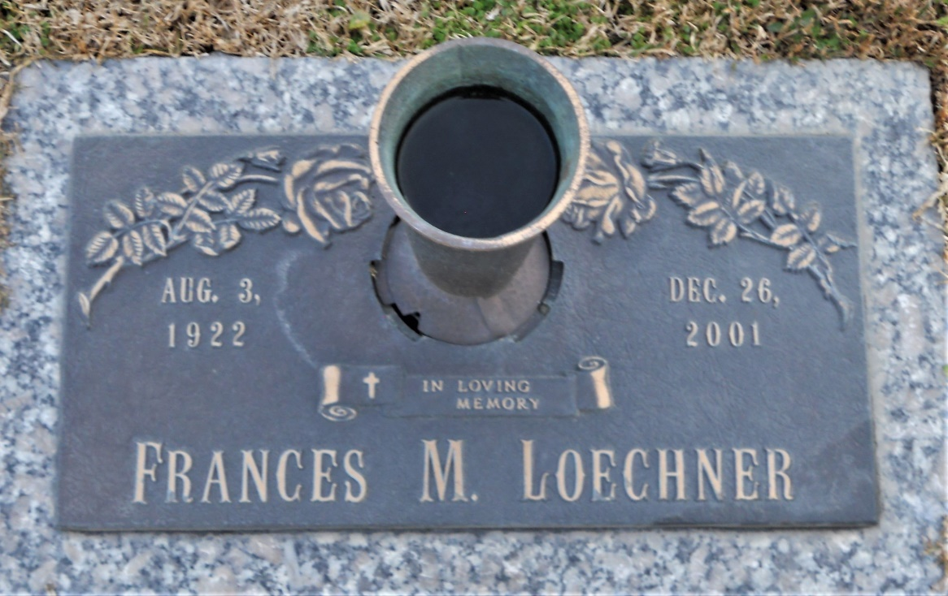

Photo by Team T Lo

Frances Plantago Loechner, 79, a native of Hammond and resident of LaPlace, died Dec. 26. She was the wife of James Loechner. She was the sister of Rose Wrobel, Mary McKnight, Josephine Sughero, Ann Luksa, Lauretta Wagner and Catherine, and Ignatius Plantago. Services were Dec. 29 at St. Joan of Arc Catholic Church, LaPlace, with interment at St. John Memorial Gardens, LaPlace.

L'Observateur, LaPlace, LA; December 29, 2001