Dorothy Hellen (Simon) Loga
November 25, 1940 – June 23, 2017

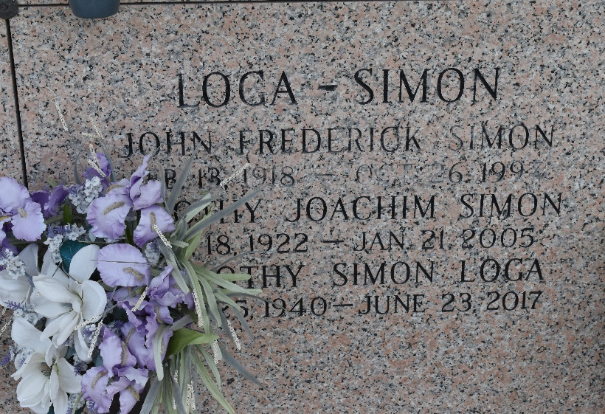

Dorothy "Dotsie" Hellen Simon Loga, born November 25, 1940, passed away peacefully on Friday evening, June 23, 2017. She was 76 years old. Beloved wife of Capt. Harold John Loga of 56 years. Daughter of the late Dorothy Joachim Simon and John Frederick Simon. Sister of Gaynell Simon Melerine. Mother in law of Joy W. Loga. Grandmother of Daphne Loga Cedre, Daniel J. Cedre Sr. and Keith H. Loga Jr. Great-grandmother of 4. One son Keith H. Loga Sr.
Dotsie was a native of Lower 9th Ward and resident of Montz for 25 years. She was a former employee of Arthur Andersen & Co. She was a member of the American Legion Auxiliary Norco Post 195 for 25 years where she held several offices and was head of the Poppy Drive for several years. She will be dearly missed by many.
Relatives and friends of the family are invited to attend her Funeral held at H.C. ALEXANDER, 821 Fourth Street, Norco, on Wednesday, June 28, 2017. Visitation will begin at 10:00 am-12:00 noon service will follow. Interment will follow in St. John Memorial Gardens, Laplace. An online guestbook is available at www.hcalexander.com.

The New Orleans Advocate (LA)
Jun. 25 to Jun. 28, 2017

