Gladys Mae (Templet) Logarbo
March 11, 1942 – September 20, 2011

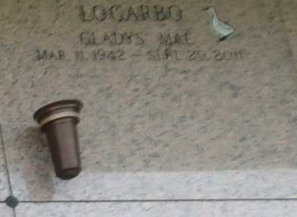

Gladys Templet Logarbo passed away on Tuesday, September 20, 2011. Beloved wife of the late August Logarbo. Mother of Charles, Ron & Danny Logarbo, Theresa Georgel, Shirley Lawrence, Barbara Cooke, Cheryl Roussel, Linda Logarbo and the late Peggy Logarbo. Also survived by numerous grandchildren, great-grandchildren and great-great-grandchildren. Daughter of the late Charles and Regina Templet. Sister of George, Jimmy, Stanley, Buck and Jackie Templet and the late Charlie Templet. Age 69. A native of LaPlace and resident of Ponchatoula, LA.
Relatives and friends are invited to attend services. Visitation at Millet-Guidry Funeral Home, 2806 W. Airline Hwy., LaPlace, LA, on Friday, September 23, 2011 from 9:00 am to 11:45 am, followed by Religious Services in the Funeral Home Chapel at 12:00 noon. Burial in St. John Memorial Gardens Cemetery, LaPlace, LA.
The Times-Picayune, New Orleans, Louisiana
Sep. 21 to Sep. 22, 2011

