Griffin Charles Lorio Jr.
December 8, 1951 - August 26, 2021

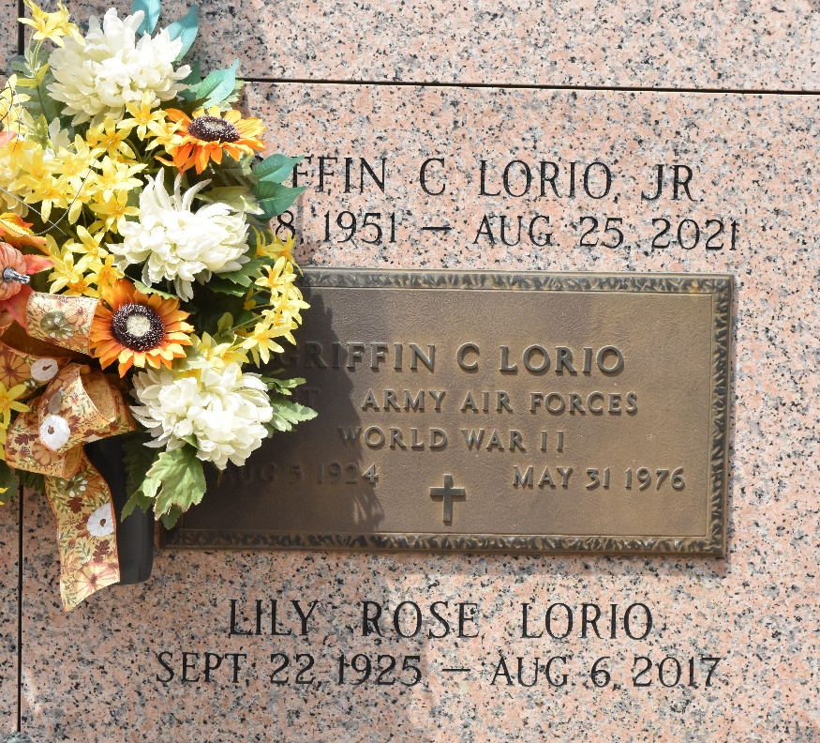

Griffin Charles Lorio, Jr. passed away on Tuesday, August 26, 2021 at the age of 69. He was a native of New Orleans, LA and a resident of LaPlace, LA. Charles attended LSU Law School in Baton Rouge, LA. He devoted over 40 years of public service as an Assistant District Attorney in St. Charles Parish and in St. John the Baptist Parish. He was so kind-hearted and would help anyone in need. He lived life to the fullest. He had such an outgoing personality. He was loved and will be dearly missed.
Beloved son of the late Lily Rose Guidry Lorio and Griffin Charles Lorio, Sr. Brother of Douglas Paul Lorio (Jeri), Gregory James Lorio (Yohanna) and Lance Joseph Lorio (Nadina). Also survived by his uncle, Eddie Joseph Lorio, Jr. (Rita).
Relatives and friends are invited to attend the Visitation and Memorial Service at Millet-Guidry Funeral Home, 2806 W. Airline Hwy., LaPlace on Tuesday, October 26, 2021 from 9:00 a.m. to 11:00 a.m. followed by a Memorial Service at 11:00 a.m. Inurnment in St. John Memorial Gardens Cemetery, LaPlace, LA.
Millet-Guidry Funeral Home, LaPlace, LA
October 21, 2021

