Gerard F. Lotz
September 16, 1932 – September 17, 2008

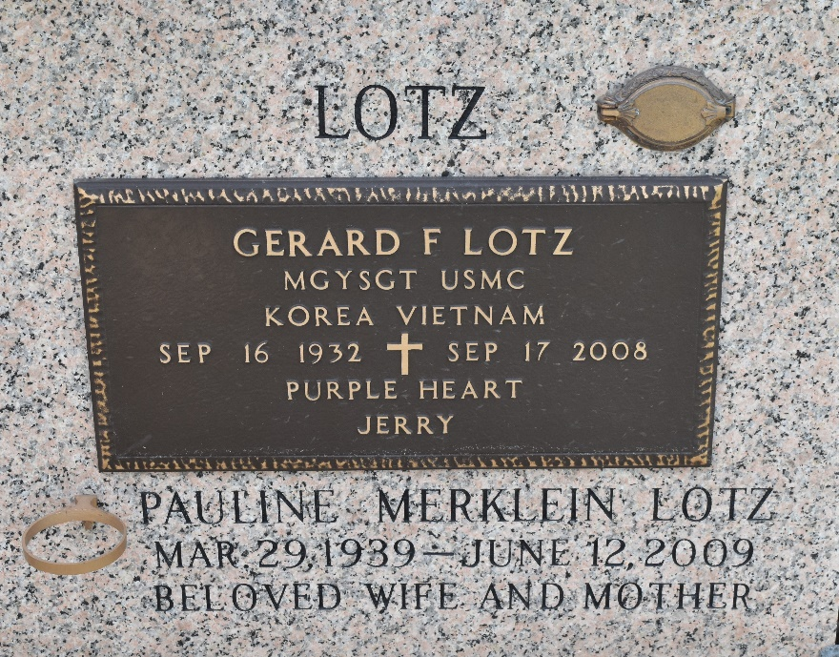

Gerard Lotz, 76, of Gulfport passed away Sept. 17, 2008, in Gulfport. Mr. Lotz was sent from the RIEMANN FAMILY FUNERAL HOME, Gulfport, to Millet-Guidry F.H. in LaPlace, LA.

The Sun Herald, Biloxi, Mississippi
Sep. 18, 2008
**

MGYSGT Gerard (Jerry) Lotz USMC, retired after 24 years of service, passed away on Wednesday, September 17, 2008 at 12:05 a.m. Beloved husband of Pauline (Polly) Lotz. Father of Gerard Lotz II, Beth Ann Lotz, Robin Myers and Jerrie Jo Downey. Step-father of Mary Smith and John Merklein. Also survived by 8 grandchildren and 4 great-grandchildren. Son of the late Frederick Sr. and Josephine Lotz. Brother of the late Louis and Frederick Lotz Jr., Josephine Palazola and America Montalbano. Brother-in-law of Agnes Lotz. Also survived by nieces and nephews.
He was a member of the River Region Art Gallery and a Veteran of Korean and Vietnam Wars. Age 76. A native of New Orleans, LA and a resident of LaPlace, LA for the past 32 years.
Relatives and friends, also VFW Post 3337, Shell Oil and MCCIA are invited to attend services. Visitation at Ascension of Our Lord Catholic Church, 1809 Greenwood, LaPlace, La. on Saturday, September 20, 2008 from 8:30 a.m. to 10:00 a.m. followed by Religious Services at the church at 10:00 a.m. Burial in St. John Memorial Gardens Cemetery LaPlace, La. Arrangements by Millet-Guidry Funeral Home LaPlace, La.

The Times-Picayune, New Orleans, Louisiana
Sep. 19, 2008

