Juanita (Reine) Louque
1942 – November 15, 2022

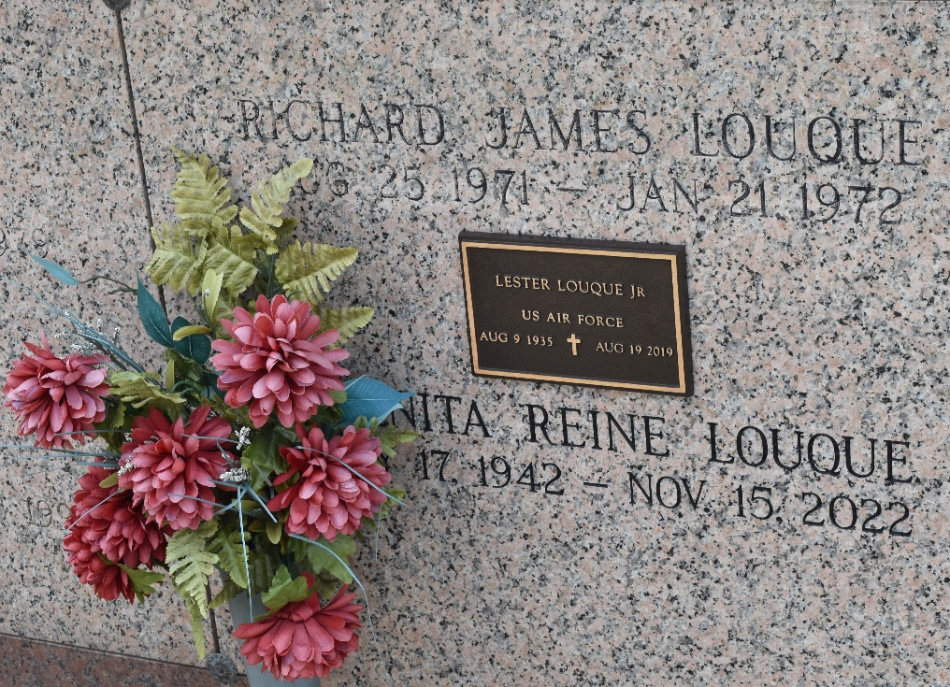

Juanita Reine Louque, a native of St. John Parish and a resident of LaPlace, LA passed away at the age of 80 on November 15, 2022. Beloved wife, for 54 years, of the late Lester Louque, Jr. Loving mother of Daniel Louque and his wife Melissa, and the late Arnold "AJ" Louque and Richard Louque. Grandmother of Alex Louque. Daughter of the late John Reine and Marie Schexnaydre. Sister of Marie Verrett and her late husband Edward, Joan Kennedy and her late husband Donald, and the late John Reine. Daughter in law of the late Lester Louque, Sr. and Noelie Haydel Louque.
Relatives and friends are invited to attend the Visitation and Funeral Mass at St. Joan of Arc Catholic Church, 529 W. 5th St., LaPlace on Tuesday, November 22, 2022. Visitation at church from 10:00 a.m. to 12:00 p.m. followed by a Funeral Mass at 12:00 p.m. Interment in St. John Memorial Gardens Cemetery, LaPlace, LA.

Millet-Guidry Funeral Home, LaPlace, Louisiana
November 17, 2022

