Lester Louque Jr.
August 9, 1935 – August 19, 2019

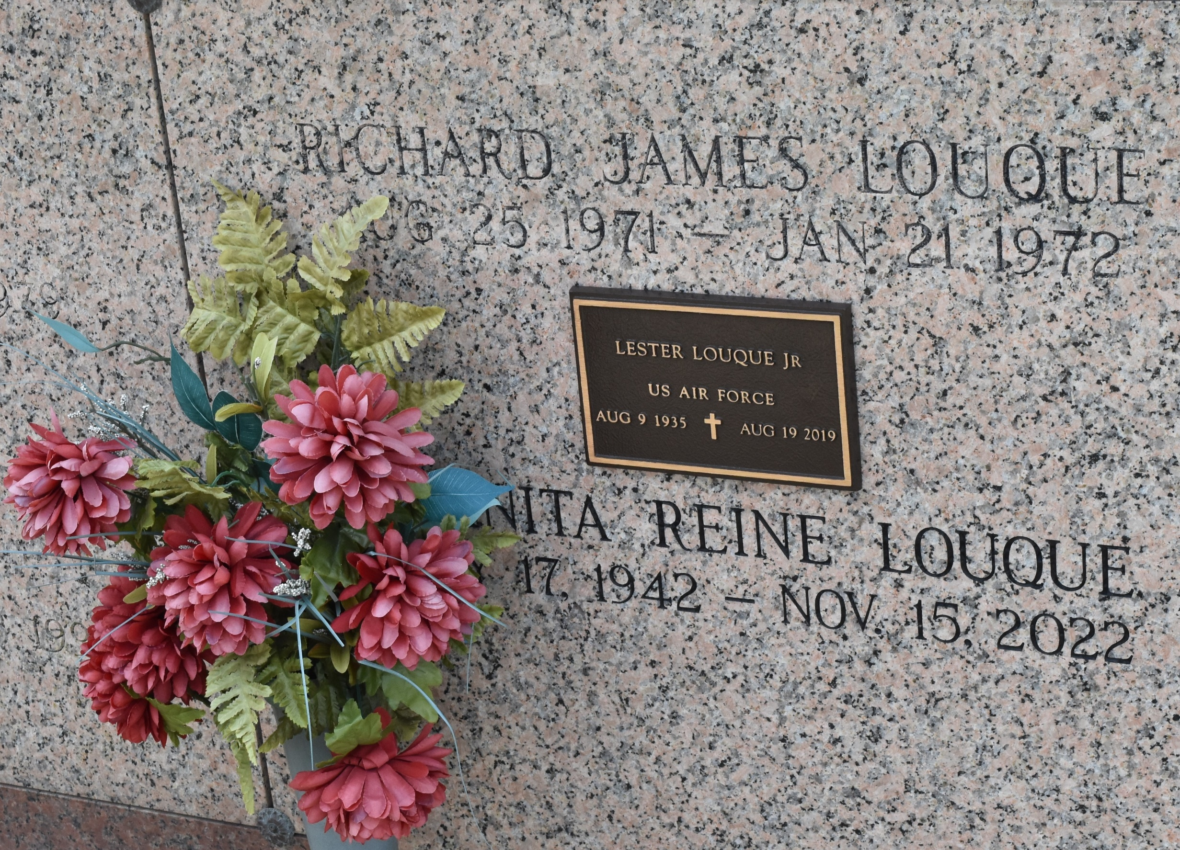

Lester Louque, Jr., a native of St. John Parish and a resident of LaPlace, LA passed away at the age of 84 on August 19, 2019.
He is survived by his wife, Juanita Reine Louque; one son, Daniel Louque (Melissa); one Grandchild, Alex; two sisters, Faye Reine (Gene), and Patricia Weimer (Daniel).
Lester was preceded in death by sons, Arnold “AJ” Louque and Richard Louque; parents, Lester Louque, Sr. and Noelie Haydel Louque.
The family of Lester Louque, Jr. would like to thank the staff of Heart of Hospice for their compassion, care and support.
Visitation will be on Saturday, August 24th, 2019 from 10:00am until 12:00pm at St. Joan of Arc Catholic Church in LaPlace, La. A Mass of Christian Burial will be celebrated at 12 Noon and burial will follow in St. John Memorial Gardens Cemetery in LaPlace, LA.

Rose Lynn Funeral Home, Lutcher, Louisiana

