Shondrea Ashon Lovette
February 7, 1986 – September 28, 2014

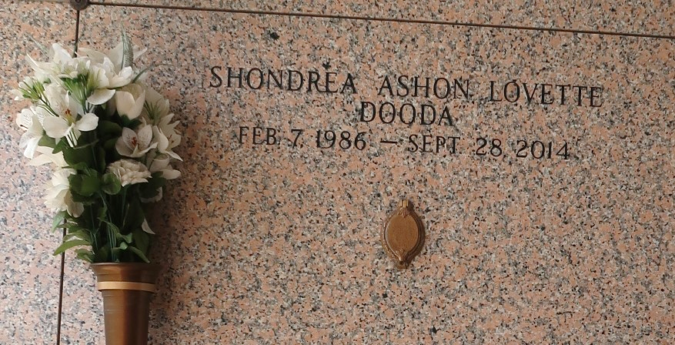

Shondrea Ashon "Dooda" Lovette passed away Sunday, September 28, 2014, at the age of 28. She was the daughter of the late Albert Lovette, Jr. and the late Shonnya Lovette, Melvin and Gina Batiste, and Delawnn Lawrence. Shondrea was the sister of Shondrica (Tremaine) Nathan, Kyroneka (Abdul) Burl, and Keir Batiste. She was also survived by grandmother Elmira Batiste; niece/godchild Kalyn Burl; godchildren Tra'Nyija Weber and Darryl Cook, III; godparents Reginald Davis and Charlotte Melancon; a host of aunts and uncles; and other relatives and friends.
Relatives and friends of the family also Pastors, Officers and Members of Beech Grove Baptist Church of Reserve, LA and all neighboring churches are invited to attend the home going celebration on Monday October 6, 2014 at 11:00 am at Beech Grove Baptist Church, 117 Beech Grove Drive, Reserve, LA 70084, on Monday, October 6, 2014, at 11:00 am. Visitation will be from 9 am until the time of service. Reverend Jeff Patterson, under the leadership of Reverend Wesley Anderson, Sr., will be officiating. Interment will be at St. John Memorial Gardens, 2205 West Airline Highway, LaPlace, LA 70068. Arrangements by Heritage Funeral Directors (504) 944- 5500. Online guest registry at www.heritagefuneraldirectors.com. Director, Carmen Barloney.
The New Orleans Advocate (LA)
Oct. 4 to Oct. 7, 2014

