Eileen (Fortenberry) Lozano
November 5, 1942 – November 17, 2020

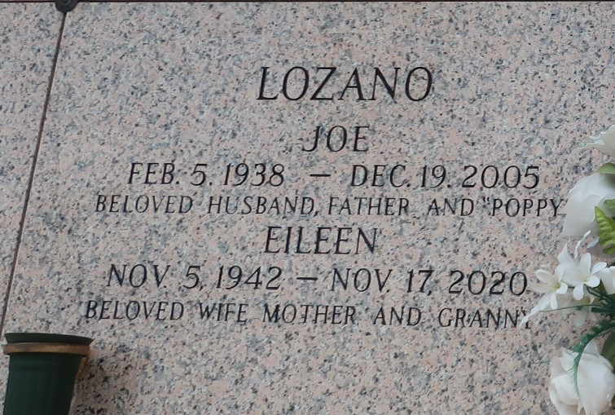

Eileen Fortenberry Lozano passed away on Tuesday, November 17, 2020 at the age of 78. She was a native of Magee, MS and a life long resident of LaPlace, LA. Beloved wife of the late Joe Lozano. Loving mother of David Lozano (Lisa), Danny Lozano and Damon Lozano. Grandmother of Brandon Lozano (Mindy), Mikey Lozano (Heather), Danielle Lozano Walia (Prabh), Michelle Lozano Hales (Dustin) and Angelle Lozano. Daughter of the late Oree Bishop Fortenberry and Grover Delton Fortenberry. Sister of Yvonne Montz, Edith Courteaux and the late Lloyd Fortenberry and Larry Fortenberry. Also survived by 10 great grandchildren.
A Private Graveside Service will be held in St. John Memorial Gardens Cemetery.
Millet-Guidry Funeral Home, LaPlace, Louisiana
November 20, 2020

