Luis Edwin Luna
Abt 1946 – March 31, 2023

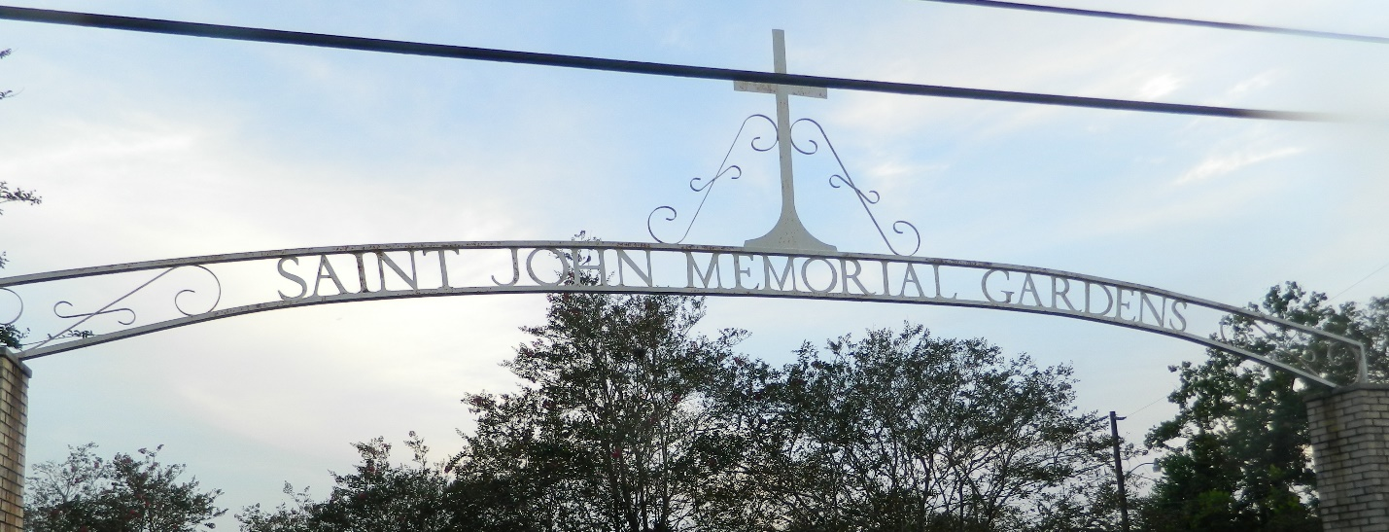

Luis Edwin Luna passed away on Friday, March 31, 2023 at the age of 77. He was a native of Tucurrique, Costa Rica and a resident of LaPlace, LA. Luis was a great teacher and mentor in the welding industry for the refineries in Norco.
Beloved husband of Rosa Mayorga Luna. Loving father of Giselle Luna, Vivian Luna Bates (Christopher) and Lisa Agnes Luna. Grandfather of Damien Evan Luna (Samantha), Lynn Thomas Vicknair, III (Rachel), Isaac Chapple and Sam Chapple. Great Grandfather of Elijah Thomas Vicknair. Son of the late Caridad Gomez Luna. Brother of Ana Isabel Castro.
Relatives and friends are invited to attend the Funeral Mass at St. Peter Catholic Church, 1550 Hwy 44, Reserve, LA on Wednesday, April 5, 2023. Visitation will be held from 10:00 a.m. to 12:00 p.m. with the Funeral Mass to immediately follow at 12:00 p.m. Interment in St. John Memorial Gardens Cemetery.

Millet-Guidry Funeral Home, LaPlace, Louisiana
April 4, 2023

