Mary Ann (Cognevich) Lyons
April 27, 1934 – June 2, 2011

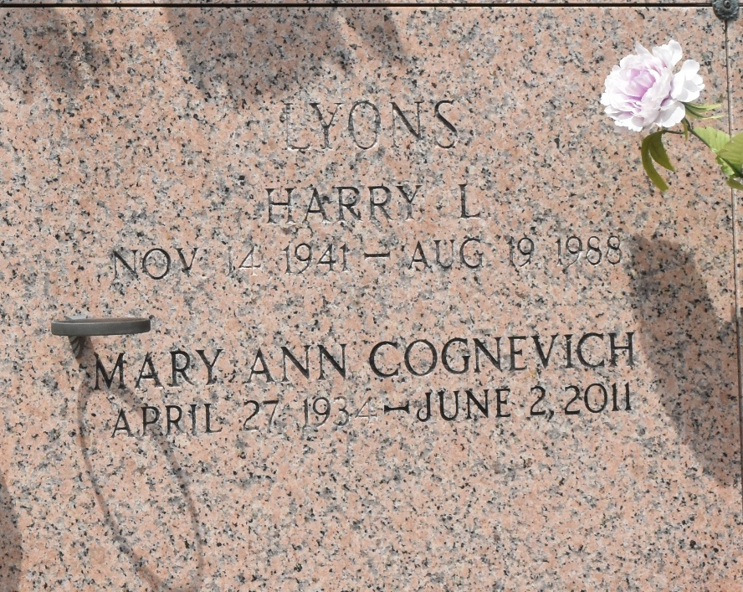

Mary Ann Cognevich Lyons passed away on Thursday June 2, 2011 at the age of 77.
Preceded in death by her parents, Carroll Cognevich and Elizabeth Colombel, her first husband Harry Lyons and her second husband Frank Myrick.
Survived by sisters Audrey Koch and Joyce Dunne; nieces Sally Haas, Sharoyn Kehlor, Mary Ann Morrison and Karen Frederick; nephews Mark Rehberg and Joseph Koch along with other relatives and friends.
Mrs. Lyons was born in New Orleans, LA and resided in Metairie, LA for 36 years. A former Dominican Sister and a life- long teacher, she was loved and will be missed by all who knew her.
Relatives and friends of the family are invited to attend a Funeral Mass at Leitz-Eagan Funeral Home Chapel 4747 Veterans Blvd. Metairie, on Thursday June 9, 2011 at 11:00 a.m. Interment in St. John’s Memorial Gardens Cemetery. Friends may visit from 9:00 a.m. until time of services. A Rosary will be recited at 10:00 a.m.
Donations in her name, to the American Cancer Society, 2605 River Rd., New Orleans, Louisiana 70121, or to the American Heart association, 110 Veterans Memorial Blvd. Suite#160, Metairie, Louisiana 70005-4952 may be made in lieu of flowers.
Online guest registry available at www.leitzeaganfuneralhome.com.

Dignitymemorial.com

