Alexander J. Mabile

July 28, 1922 – December 30, 2005

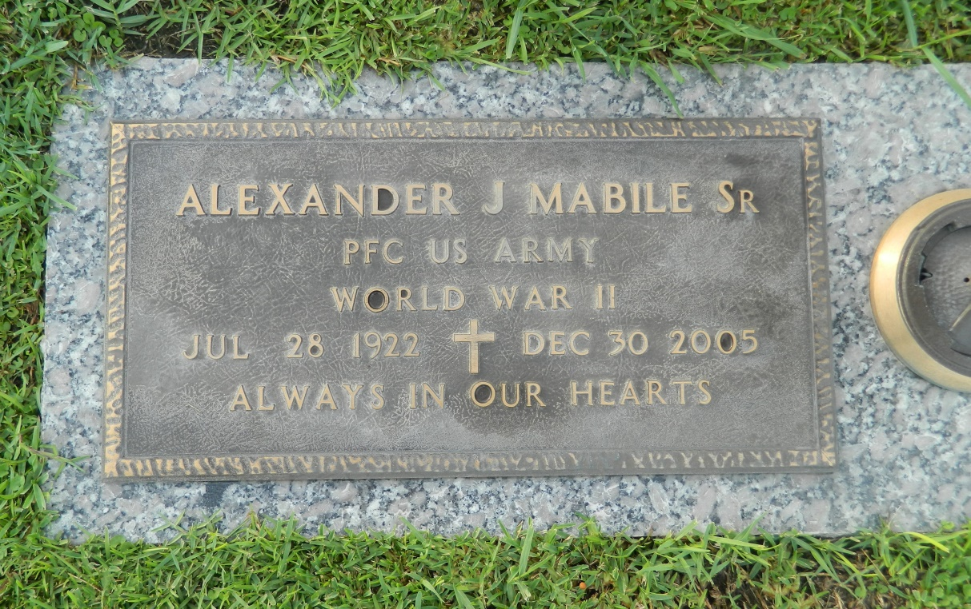

Alexander J. "Alex" Mabile Sr. died on Friday, Dec. 30, 2005, at 6:15 a.m. He was the beloved husband of Marie Womble Mabile, father and father-in-law of Jackie and Raymond Liotta, A.J. Jr. and Helen Mabile and Terry and Marsha Mabile. He is also survived by seven grandchildren and eight great-grandchildren. He was the son of the late John and Octavie Haydel Mabile. He was preceded in death by three sisters and seven brothers. He was 83, a native of White Castle and a resident of LaPlace.

Relatives and friends of the family are invited to attend services. Visitation at Millet-Guidry Funeral Home chapel, 2806 W. Airline Highway, LaPlace, on Monday, Jan. 2, 2006, from 9 a.m. until religious service at noon. Interment in St. John Memorial Gardens in LaPlace. In lieu of flowers, donations preferred to Disabled American Veterans.

Advocate, The (Baton Rouge, LA) - Saturday, December 31, 2005

Contributed by Jane Edson