Bert Mabile
September 5, 1951 – March 17, 2008

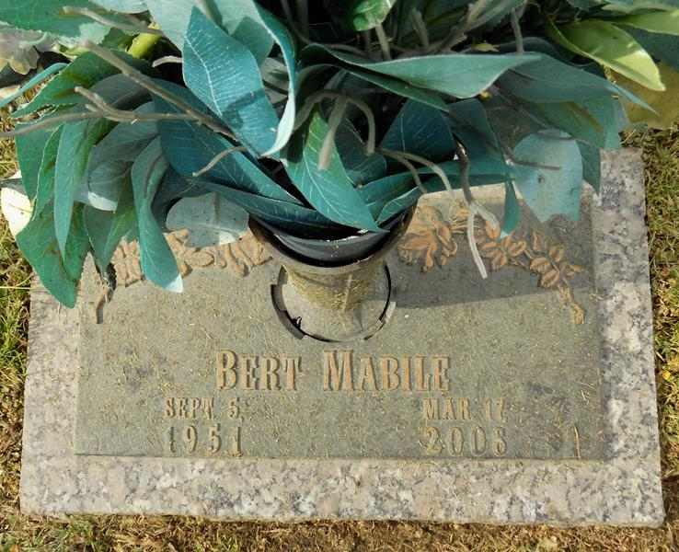

Bert Mabile on Monday, March 17, 2008 at 3:33 p.m. Beloved son of the late Morris and Martha Mabile. Brother of Morrie Mabile, Jr. and Gail Skipper. Also survived by nieces, nephews and cousins. Age 56 years. A native of and resident of LaPlace, LA.
Relatives and friends of the family are invited to attend services. Visitation at MILLET-GUIDRY FUNERAL HOME, 2806 W. Airline Hwy., LaPlace, LA on Wednesday, March 19, 2008 from 8:00 a.m. until 10:00 a.m. Followed by Religious Services in the Funeral Home Chapel at 10:00 a.m. Burial in St. John Memorial Gardens Cemetery, LaPlace, LA.
Times-Picayune, The (New Orleans, LA)
Wednesday, March 19, 2008

