Marie (Womble) Mabile

March 6, 1925 – September 26, 2004

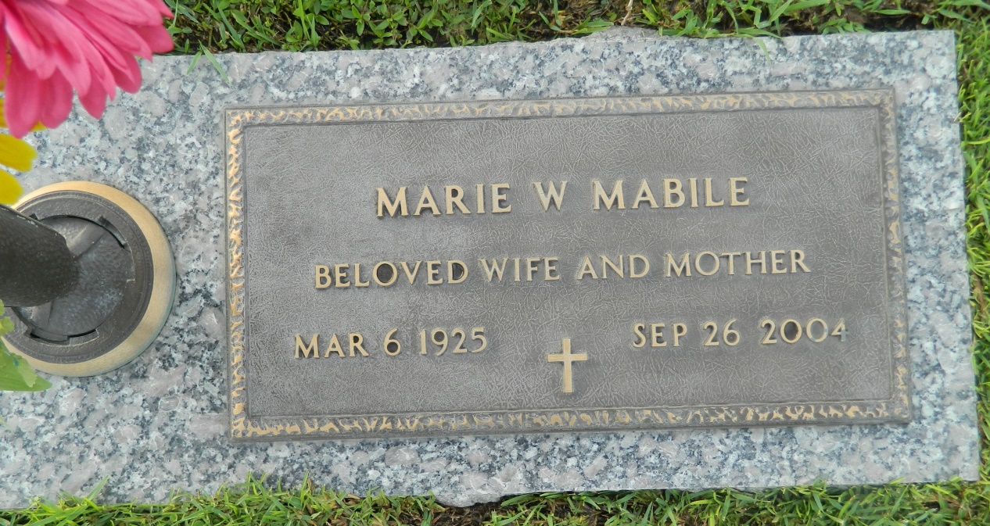

Marie Womble Mabile on Sunday, September 26, 2004 at 2:40 am. Beloved wife of Alexander Mabile for 58 years. Beloved mother and mother-in-law of A.J. Jr. and Helen Mabile, Terry and Marsha Mabile and Jackie and Raymond Liotta. Beloved grandmother of A.J. III, Matthew and Jared Mabile, Joe Liotta, Rachel L. Stanga, Raynell L. Siener and Marcy M. Hopkins. Also survived by 8 great grandchildren. She worked for Dr. Remy Gross for 22 years. Was a volunteer worker for the St. Joan of Arc Thrift Shop and enjoyed volunteer work since she retired. She will be sadly missed by family and friends. Age 79 years, a native of Merry Oaks, North Carolina and a resident of LaPlace for the past 47 years.  
  
Visitation at Millet-Guidry Funeral Home, 2806 W. Airline Hwy., LaPlace, La. on Tuesday, September 28, 2004 from 9am to 12 Noon. Followed by Religious Services at the Funeral Home Chapel at 12 pm. Burial in St. John Memorial Gardens. Cemetery LaPlace.

Times-Picayune, The (New Orleans, LA) - Monday, September 27, 2004

Contributed by Jane Edson