Leroy George Macha Sr.
August 15, 1938 – November 20, 2016
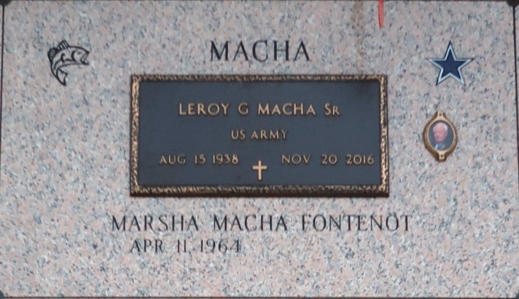

LEROY GEORGE MACHA SR., born on August 15, 1938 in East Bernard, Texas, passed away peacefully on November 20th, 2016 in LaPlace, LA. He is preceded in death by parents: George and Olga Macha, and a great grandson, Trevor Dodson.
A man of Faith, he was a member of First Baptist Church in LaPlace, La. where he fellowshipped weekly with his beloved bible study group. Leroy retired from Chevron in 2003, after a very long career in the petro chemical industry. An avid fisherman, hunter and gardener with a passion for carpentry. Family was important to him in addition to being a lifelong Dallas Cowboys fan, he was true to the "silver and blue" and that was evident to all who knew him well.
Leroy is survived by 3 children: Marsha Fontenot, Cecilia Macha (Duane), and Leroy G. Macha Jr. (Debbie). 1 sister: Irene Macha Haas and 2 brothers: Daniel Macha (Geraldine), and George Macha (Rosa Lee). 5 grandchildren: Christopher Fontenot (Kady), Jared Ponce, Wesley Dodson, Ryan Ponce, and Jillian Macha and 4 great-grandchildren.
A viewing will be held at The Baloney Funeral Home located at 1905 West Airline Highway, LaPlace, LA. 70068 on Tuesday, November 22nd, from 2:00-5:00PM. The funeral services will be held at First Baptist Church, located at 120 Ormond Blvd., LaPlace, LA. 70068 on Wednesday, November 23rd, 2016 at 10:00 AM, officiating, Pastor Paul Nayler. Visitation at the Church begins at 8:30AM until time of service. Interment, St. John Memorial Gardens Cemetery, 2205 West Airline Hwy., LaPlace, LA. 70068. The Repass will be held at First Baptist Church, immediately following the service. Funeral arrangements entrusted to The Baloney Funeral Home located at 1905 West Airline Highway, LaPlace, LA. 70068 (985) 224-8460.

Baloney Funeral Home, LaPlace, Louisiana

