Betty (Tassin) Madere
February 16, 1945 – March 8, 2014
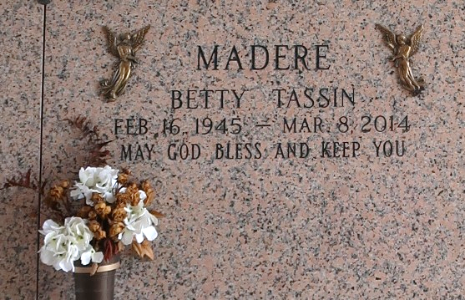
Betty Tassin Madere died on Saturday March 8, 2014. Former wife of Clyde Madere Sr. Mother of Christine M. Torres (Kevin), Danette M. Brignac ( Ricky), Clyde Madere Jr. and Stephen Madere (Tina). Grandmother of Christopher, Ross, Chelsey, Emily, Matthew, Cameron, William, Tristan, Savannah, Nicholas and Kortni. Daughter of the late Walson and Heloise Tassin. Sister of Lilly Dufrene, Shirley Evans, Dorothy McConathy and the late Fay Duhe and Jeanne Perilloux. She was the St. John Register of Voters for 36 years. Age 69. A native and resident of LaPlace, LA.
Relatives and friends are invited to attend services. Visitation at St. Joan of Arc Catholic Church, LaPlace, LA on Tuesday March 11, 2014 from 9:30am to 11:30am, followed by Mass at 12:00 noon. Burial in St. John Memorial Gardens Cemetery, LaPlace. In Lieu of flowers donations preferred to Danielle's Inn (Home for Unwed Mothers). Arrangements by Millet-Guidry Funeral Home, LaPlace, LA.

The Times-Picayune, New Orleans, Louisiana
Mar. 8 to Mar. 9, 2014

